ELINOR’S TOWN
Composting
PREMISE P011 – V2 – Jan. 21, 2019

Elinor’s Question: Who rakes the leaves in the forest?
Logline: Elinor learns that the forest does its own composting.
Curriculum Goals:
LS5. Begin to understand that animals and plants depend on other living things and
nonliving things in the environment to meet some of their needs: (Elinor realizes the plants in the forest and the garden depend on the composting leaves for some of their food)
ND – None?
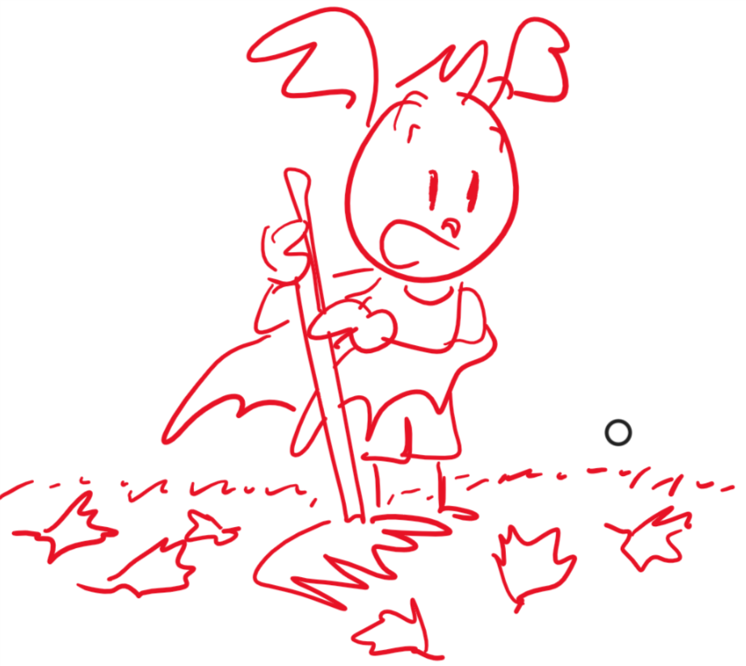
SEP
Elinor, Hazel and Ari are helping Ari’s Dad rake the leaves in their yard. Ari does so happily, and Elinor and Hazel help him out, but of course, (as preschoolers) they play as much as they help, throwing the leaves up into the air and making it rain, piling up the leaves and then jumping in the pile, making “leaf birds” (like snow birds). Eventually they (almost accidentally) get all the leaves piled into one spot more or less. Yes! Job done, the kids are ready to get on with their happy play day when suddenly a few more leaves drift OS. Uh-oh, job not done. Ari rakes them up but a few more drift OS. Where are these leaves coming from? They follow the drifting leaves to the (very close) nearby forest and Ari’s eyes pop! Oh, no! SO MANY LEAVES!! Is he going to have to rake them all? Hazel and Elinor are sure he won’t have to – but it does lead to an interesting question: “Who rakes the leaves in the forest?” They need more observations.

Elinor and her friends decide to investigate. Hmmm, the whole forest would be brimming FULL of leaves, unless someone is raking them up, but who? They walk a few paces into the surrounding trees while throwing around ideas: maybe the trees rake their own leaves; maybe it’s the birds or the wind who pick up all the leaves. The kids decide none of those seem likely, and they start to collect leaves to observe them. They look at the leaves closer and notice that some of them are fresh, others are a little worn, and others still are really old and crumbling. Then they notice some of the dirt on the ground has little bits of leaves in it, and they piece together that leaves that fall on the forest floor eventually get old and go back into the soil.

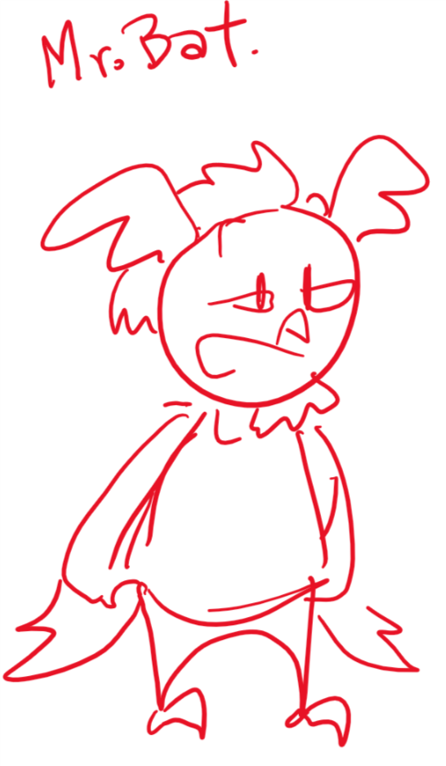
Back at Ari’s house, the kids inform Ari’s Dad of the results of their investigation. Mr. Bat confirms that leaves do indeed get old, break down and turn back into soil. We call this “composting”. In the forest this happens naturally on the forest floor and it helps to feed the trees. Then Elinor looks at the piles of leaves they picked up in Ari’s yard and wonders if they can turn them back into soil. Mr. Bat says that, actually, that was the plan all along. He shows them a compost piles in the corner of the yard (this mimics the forest environment). He uses a hand-cranked chipper chips the leaves and makes a new pile. Then he shows the kids an adjacent older pile where the leaves have already brokendown. He dig around and pulls out some soil from the bottom, and shows them some worms, who help with the process. Then he mixes in some of the new leaves and says by next spring there will be lots of lovely soil to spread on the garden. Elinor can’t wait to see all the spring flowers and Ari’s just glad he doesn’t have to rake all the leaves in the forest.

Sara Sweetmen Notes:
I like this premise. I can imagine their thought bubbles when they are thinking about how all the leaves would pile up in the forest over time. The idea of long time frames and large amounts can sometimes be tricky for preschoolers so you will want to give them as many visual and verbal cues as possible with little distractions. This story has the opportunity of teaching the viewers that "we need more observations" sometimes means looking/ sensing in more places and sometimes means looking/ sensing more closely. In this case they need to look closer, and closer, and closer to discover what is happening to the leaves. Maybe introducing a hand lens would be good.

