ELINOR’S TOWN
Special Places
PREMISE 16 – V2 – 29 November 2018

Elinor’s Question: Why do birds build nests, and dogs bury bones?

Logline: When Ari misplaces the group’s favorite ball, they discover that he needs a system for keeping track of his things.

Curriculum Goals:
LS8. Begin to understand that there are many different kinds of living things and how they may be the same or different: i.e. The bird, ant and dog are very different animals, but they all have similar behaviors in that they store things that are important to them in designated places. Observe and describe similarities and differences across different types of plants and animals c. Group different kinds of living things into categories based on basic similarities and differences d. Identify seasonal adaptations in physical characteristics or behaviors of animals (? Not sure which LS goal is the closest)
ND3. (RTL Crosscutting concept ‘Structure and Function’): Understand that structures and materials in the natural world can be used or can inspire the engineering of structures with similar function in the designed world. i.e. the kids adapt the natural world idea of finding “special places” to store things to help Ari clean his room.
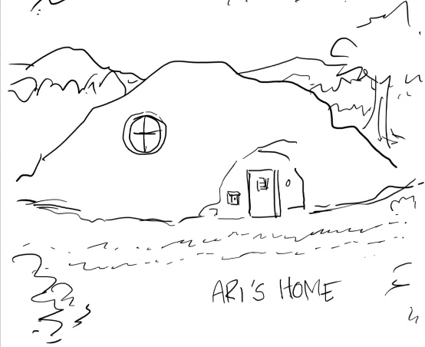
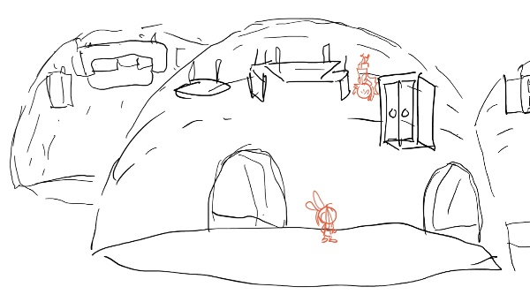
OPEN ON ELINOR, and HAZEL outside of the Bats’ house/cave, waiting for their friend Ari to come out and play. It’s a sunny Saturday afternoon, and they want to play with Ari’s super bouncy ball. ARI comes out and is ready to go. But where is the ball? Ari says he couldn’t find it. Ari tells Hazel and Elinor not to worry – he’s got a perfect system. First he looks everywhere the ball ISN’T, then he’ll remember where it IS. They go into the house to look in Ari’s room. We see a medium shot of Ari standing by his bed and dresser, and everything looks neat. Ari says he doesn’t understand why people say he’s messy. The camera pulls out and rotates to show that Ari is actually hanging from the ceiling, and all the furniture is bolted upside down. Elinor gasps, “What a mess!” as she and Hazel stand among a huge clutter (everything from school papers to bath towels to toys and clothes) in the real floor of the room. Elinor, Hazel and Ari turn over some of the clutter in Ari’s room and determine there’s no ball there. “If it’s not in my room, I know exactly where it is,” Ari declares with confidence. “Where?” asks Elinor. “Somewhere else!” Elinor and Hazel remind Ari they want to play before this whole beautiful day is over. Elinor has an idea: If you retrace your steps, you’ll find it. They ask Ari to take them on a tour of everything he did that morning. We need more observations!

Outside in the yard, Ari remembers the first thing: He was playing with the ball, but then his dad asked him to rake the leaves. There’s a basket of apples in the yard, and Ari picks up one and offers some to Elinor and Hazel, who decline. The kids decide to look around. As they look around (in the leaves pile, around the yard…) Elinor curiously notices a bird in a branch overhead, busily adding to its nest, where three little eggs rest. Elinor watches the bird for a minute, observes to Ari (munching on the apple) that the bird keeps its eggs in the nest – Elinor wonders why the birds build nests, but before she can dig deeper, Hazel comes up and says the ball is nowhere to be found. Ari suddenly remembers – Oh yeah, before he could rake the leaves, he needed the rake! Maybe that’s where he left it…! Ari leads them to the back of the house. Ari remembers he practiced the “toss and spin” move here: you throw the ball up, spin around, then catch it. He demonstrates without the ball, pointing out that it’s even more impressive WITH it. The kids look around again. As they are looking, Elinor curiously observes an ant carrying a leaf to a hole in the ground. Interesting. She points it out to Ari, but before they can think more about it, Hazel tells them the ball is not here, although she did find the rake, but it’s broken! Ari remembers what happened next: the rake was broken, so he went to borrow one from their neighbor, Mr. Dog.

The kids walk over to Mr. Dog, who they catch burying a bone with a shovel. Mr. Dog greets Ari again and explains he has all kinds of shovels. Elinor asks him why he’s burying the bone, and Mr, Dog explains he has a spot where he keeps his bones to save for later. She thinks for a moment and then declares, “That’s so interesting!” and connects what Mr. Dog is doing to the other things they observed (ants carrying food or leaves to their holes in the ground, and birds building nests.). What they all have in common is they’re putting things that are important to them in special places where they can find them again! “You’ve got THAT right,” Mr. Dog confirms. So, if Ari had put the ball away in a special place, they would have been able to find it again today. Mr. Dog tells them he remembers Ari had the ball, but hasn’t seen it since. Suddenly, Ari’s stomach growls. Ari really wants to remember where the ball is, but says he can’t concentrate because he’s too hungry. All he’s had to eat so far is the apple. Ari suddenly remembers: I know where I left the ball! They go back to the yard, and Ari tells them that after he raked the leaves he was so hungry he ate an apple. He checks the apple basket and, sure enough, one of those apples is actually the ball! Ari: See? My system works perfectly! Ari is ready to play, but Elinor and Hazel ask him if maybe there’s something they should do first. Ari says, oh yeah. Cut to a little later and Elinor and Hazel are helping Ari tidy up his room, making a place for everything (except he has to help them reach up to the ceiling to put his clothes into his closet!) As they finish, Ari realizes he can’t find the ball again! Oh, NO! Ari and Elinor think they have to start over. But Hazel has it behind her back – FOOLED YA! Let's play.

