ELINOR’S TOWN
The Lizard Lounge
PREMISE P041 – V1 – November 15, 2018

Elinor’s Question: Why do lizards sit in the sun?
Logline: The kids learn that lizards use the sun to warm themselves
Curriculum Goals:
- LS:
- ND.

This is all great, I LOVE the fact that no one harasses the lizards, maybe we can make a bigger deal (well, they got here first and so it’s their dibs, fair is fair) All the beats are in the right place. I am happy to send this through and see what others think. As we develop, some of the questions I might ask are..

- Can we make this more personal to Elinor. Maybe she is REALLY enjoying the sunshine off the top, and quickly noticing other living things that are as well (sunflowers, birds in a birdbath), which would explain why Ari is getting so hot – Elinor (the sun bunny) is AVOIDING the shade.
- Then Elinor spots the PERFECT SUNNY SPOT across the park – laaaa! That’s where’s she’s like to be! Really? But there’s no shade! And when she gets there it turns out Ms. Beaver had the same idea, but
- Do we need Mom? Not crazy about the “leading questions” she’s asking here and would prefer the kids ask questions themselves. And maybe make a few more observations before they head to the book. Maybe look more closely at other creature/plants and notice their sun-loving behavior. Maybe one of the lizard’s scurries over to a puddle to drink, but then scurries right back.
- Would take some time setting up the Lizard lounge, make it really nice, maybe with some water nearby, pretty rocks for decoration, maybe food? Worms? The Lizard Lounge is the fun part! They should be REALLY EXCITED when the lizards decide to join.

Elinor and her mom and her friends are on a walk in the forest. It’s a sunny day and Ari complains that it’s very hot. He spots a bush and squeezes himself under it to get some shade. They continue on and spot Mrs. Beaver, who is in the middle of a construction project for a new park bench. Ari says it sounds like a great idea, if they make it a shaded bench. Unfortunately, though, all construction has come to a halt, as there are two lizards sitting on a rock right where the bench is supposed to be built. The lizards won’t budge, and they can’t shoo them away. The lizards eventually leave at the end of the day, but they come right back each morning. Mrs. Beaver is afraid they’ll have to cancel the whole project.
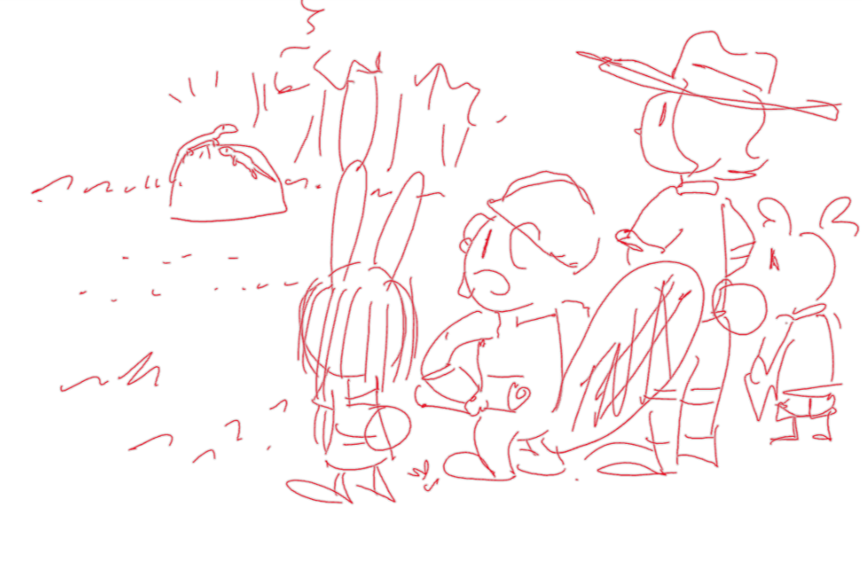
Elinor wonders why the lizards are just sitting on the rock in the sun. Elinor’s mom suggests that if they knew why, maybe they could figure out a way to get them to move to a different rock. The kids come up with different ideas for why the lizards might be sitting on the rock. Are they enjoying the view? Are they playing some very slow game? Hazel looks up lizards on her nature book, and we learn some basic facts about lizards, including the fact that they can’t get warm by themselves. Ari says he doesn’t understand why they would want to sit there, because it’s so hot! He looks for some shade, which makes Elinor hypothesizes that maybe the lizards are just trying to get warm. That would explain why they move at the end of the day when the sun is gone.

Elinor devises a plan: if they can shade the rock, maybe the lizards will want to move to a different rock. They find a different rock and move some branches to make it sunny, and then Ari hovers over the lizards (working up quite a sweat). Soon, the lizards decide to move to the other rock, and everyone cheers. Now the lizards can get warm, and Mrs. Beaver can finish the project. As Mrs. Beaver resumes her work, a tired Ari plops down in a different rock in the shade and wishes he was cool like the lizards, in more ways than one!

