ELINOR’S TOWN
EP 111 Lizard Lounge
By: Jorge Cham and Daniel Whiteson
OUTLINE – Dec 20, 2018

Elinor’s Question: Why do lizards sit in the sun?
Logline: The kids learn that lizards use the sun to warm themselves
Curriculum Goals:
LS3. Understand that all animals need food in order to live and grow, that they get their food from plants or from other animals, and that plants and animals need water and light to live and grow: Elinor will observe that the lizard needs sunshine.
ND4. (RTL Crosscutting concept ‘Flows, Cycles, and Conservation’): Appreciate the
way that elements in the natural world change, interact and are re-used, and how we can
organize our designed world to better fit and care for the environment. Elinor will rearrange the rocks and other natural things in the park to create the Lizard Lounge.

SEP1b: Ask more complex questions about observable phenomena [ They ask why the lizards are choosing this rock specifically ]
SEP3b: Compare and contrast objects and events by describing similarities and differences in detail [ comparing the feeling of shade and sun ]
SEP6a: Use background knowledge experiences, and data to construct reasonable explanations and theories of natural phenomena [ The kids hypothesize why the lizards sit on that rock ]
SEP7: Engaging in argument from evidence [ Elinor reminds them that lizards only sit on rocks during the day ]
SEP8b: Obtain information using various age-appropriate texts, text features, and other media to help answer a question and/or support an explanation [ Hazel looks up lizards]
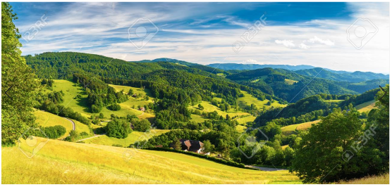
1. EXT TRAIL -- DAY

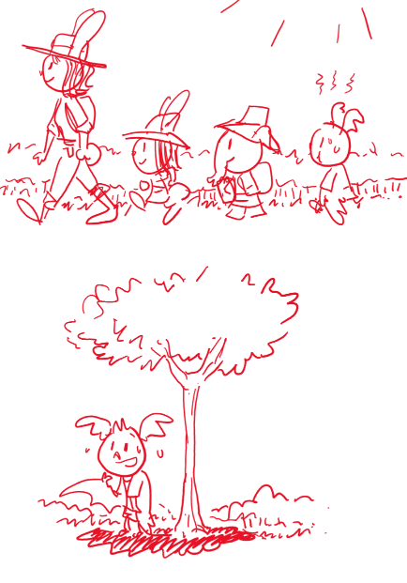
Open on Ranger Rabbit hiking along some open hills with Elinor, Ari and Hazel. It’s a beautiful scenery and the sun is out in full force. The setting is thin and open, mostly bushes and just a few trees, so there is not much shade. Ranger Rabbit is out surveying and the kids are having fun tagging along. Elinor smiles at a butterfly that flies by and giggles at two birds singing in a tree, while Hazel makes drawings on her notepad. Ranger Rabbit exclaims what a WONDERFUL day it is to be out on a hike. Elinor and Hazel agree. They are both wearing sun hats, as is Ranger Rabbit. Ari, on the other hand, is not. He is walking a bit behind, visibly hot. Phew! He tells the girls to wait up. How can they go so fast? They stop to let him catch up. Ari, who just happens to stop under a small tree, drinks a whole bunch of water. Aahhhh, he feels so much better. In fact, he’s not that hot anymore! Let’s go! But as soon as he steps out of the shade, he starts to feel hot again. Phew! He falls a little behind again. Wait up! He stops again to catch his breath and again just happens to stop under some shade. Oh, he feels much better! Suddenly, it dawns on him. He steps out into the sun and feels hot. He steps back in the shade and feels cool. Elinor and Hazel tell him of course he feels hot! The sun is warming him up! Ranger Rabbit fashions a makeshift parasol out of a tree branch for him and they keep hiking.

As they keep walking, they hear some voices ahead. They walk down the trail to see what is going on.

2. EXT CLEARING -- DAY

They don’t walk far and come around to see Mrs. Beaver and a few other animal construction workers. Mrs. Beaver is looking preoccupied as she talks to another worker while holding open a big set of blueprint plans. “Nope, nope, that just won’t do…” they hear her say as Ranger Rabbit and the kids walk up. Ranger Rabbit asks Mrs. Beaver what’s wrong, and Mrs. Beaver explains that her crew is supposed to install a new park bench in that spot over there (she references the same spot on her map). What’s the problem, asks Ranger Rabbit? The problem is that there’s a rock where the bench is supposed to be. I see, says Ranger Rabbit. We could move the rock, says Mrs. Beaver (one of the workers is a really strong buffalo), but there’s another problem: there are two lizards lounging on the rock, and they just won’t budge.

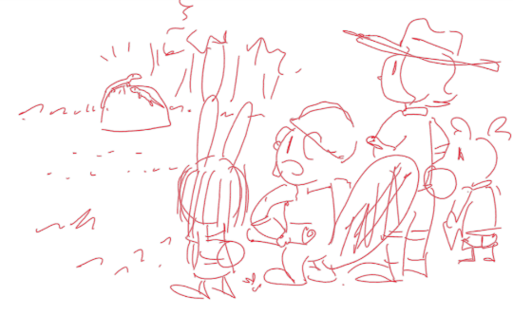
Elinor and Hazel are listening intently to this conversation, but Ari looks around for somewhere to sit. He spots a perfect spot: near them is another rock, which just happens to be under a small tree. He walks over and sits down: Aaahhh… Now he can put down the branch, which wasn’t covering him all that well anyway.

Back to the conversation, Mrs. Beaver explains they’ve tried everything, from waving at the lizards, to trying to communicate with them, to calling them from afar. Hmm, says Ranger Rabbit. Hmm, repeats Elinor. Hazel asks if the lizards ever move, and Mrs. Beaver says they do leave at the end of the day, but then they come back out early the next day. They are always here first, and fair is fair. Elinor asks if they can build the bench elsewhere, but Mrs. Beaver says, no no no… The plan says to build the bench right there. They can’t build it anywhere else! Ranger Rabbit says Hmmmm…. (she seems to appreciate that this might be more of a personality problem than a real problem). Mrs. Beaver says that unless they figure something out, they’ll need to cancel the whoooole project.

While Mrs. Beaver shows the plans to Ranger Rabbit, Elinor and Hazel talk. Elinor thinks it’s really interesting: why do the lizards come back to sitting on that rock every day? Ari comes over. He yells at the lizards: “Hey! There’s another rock over here that is muuuuch cooler!” Elinor and Hazel wonder why the lizards are choosing this rock? That is SO INTERESTING! If they know WHY the lizards are sitting there, maybe they can figure out a way to get them to move! They need MORE OBSERVATIONS!

The kids sit down and go into observation mode, staring at the lizards in the rock from a few paces over. Elinor asks aloud, “I wonder why they sit in that rock?” Hazel says maybe they like the view? Ari wonders if they playing a super long game of freeze tag? But Elinor reminds them that the lizards only sit on the rock during the day.

Hazel looks up lizards in her nature book. We learn some cool facts about lizards: they mostly eat bugs (Elinor and Hazel make a face, but Ari sounds interested) and worms (all the kids: yuck!) and fruits (kids: yum!), they lay eggs like birds (Elinor thinks that’s awesome), and they can’t get warm by themselves.

Ari says he’s getting too hot and is going to go back to the nice cool rock. Elinor puts the pieces together: that’s it! She figures out that the lizards are sitting on THAT rock because it’s sunny and WARM, rather than the other shady rock where is COOL. Hazel agrees, adding that it also explains why the lizards leave again at the end of the day when the sun goes down.

Excited, they explain to Ranger Rabbit and Mrs. Beaver their hypothesis. Ranger Rabbit confirms that some animals like lizards can’t get warm by themselves and use the sun to warm themselves up. Mrs. Beaver says she doesn’t care why they are parked there, as long as we can get them to move! But how??

The kids go into problem-solving mode. Since they know that the lizards just want to be in the sun to get warm, somehow they have to get the sun OFF of this rock and ON to the other rock. They think that will make the lizards want to move.

First step is to make the other rock attractive to the lizards. They go back to the rock in the shade and get Mr. Buffalo to roll the rock over a few feet into the sun. Elinor says: “Perfect, just the way lizards like it!” Hazel suggests a few other things to make it into the perfect “Lizard Lounge”. They collect stuff to make it the perfect Lizard Lounge. As they work, they sing a song:

This will be the perfect spot
For lizards to come get hot

Worms look really gross to eat
But Lizards think it’s quite a treat!

Lay some apple slices around
To make the perfect Lizard Lounge!

They find a few worms and lay them on the rock. Then they go back to Mrs. Beaver’s rock. The lizards are still there. They haven’t noticed the Lizard Lounge. The kids try talking to them, pointing and giving exaggerated sales pitches for the Lizard Lounge but of course the lizards ignore them.

Elinor suggests that they have to make this rock less sunny so the lizards like it less. But how can they do that? Ari stretches his wings out in frustration saying “We’re never going to figure this out” and in doing so makes a big patch of shade in front of Elinor. She realizes that they can use Ari!

They get Ari to fly up and hover above the lizards, using his wings to shade the rock. He’s working up quite a sweat and the lizards shift slightly but don’t move. “Elinor, I can’t fly forever!” Elinor encourages Ari to hold on for another moment. Just as he is about to give up, the lizards start to move. They slither off Mrs. Beaver’s rock and go over to the Lizard Lounge. Everyone cheers and Mrs. Beaver is very grateful. Now the lizards can enjoy the sun and Mrs. Beaver can finish her work!

As Mrs. Beaver and Mr. Buffalo resume their work, a tired Ari plops down on the grass and wishes he was cool like the lizards, in more ways than one!

