ELINOR'S TOWN
EP 109 Why Are There So Many Different Kinds of Plants?
By: Dave Dias
OUTLINE V3 – January 7, 2018

Elinor's Question: Why are there so many different kinds of plants?

Logline As Elinor searches for her role on the soccer team, she notices that there are many different kinds of plants in the forest and realizes there can be many different kinds of soccer players too!

Curriculum Goals:
LS8. - Begin to understand that there are many different kinds of living things and how they may be the same or different. (Elinor notices that all her friends have different soccer abilities, in the same way there are many different kind of plants, all with their own attributes)
SEP7. Engaging in argument from evidence: a. Engage in discussions before, during, and after investigations. b. Support thinking and argue ideas with evidence.(Elinor discusses her observations with Ms. Mole and through the song she comes to the conclusions that everyone is good at something.)

1.EXT. SOCCER FIELD BORDERING FOREST – DAY
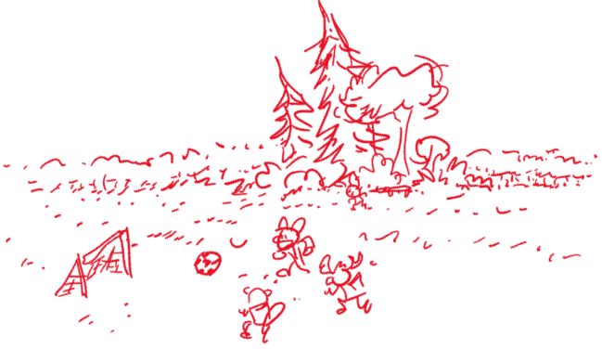
MS. MOLE leads Elinor's CLASSMATES - HAZEL, ARI, SALLY BEAVER, SILAS CHEETAH, TITO MOUSE, and the GOAT TWINS - out into a field near the school, holding a SOCCER BALL. "Let’s play soccer!", Ms. Mole bellows, and she kicks the ball - quite far! Some of the kids race after it as a group. Elinor, Hazel and Ari stay behind, each with their own ball. Elinor says she is SO EXCITED ABOUT running and playing and kicking the ball. Hazel is less sure she’ll do well, and Ari, with his usual bravado, tries a few fancy moves, only to slip on the ball and do a little backflip – whoops!

Ms. Mole calls out to them to gather around, and the kids regroup around her. Ms. Mole explains that soccer is a game that you play with a ball in all kinds of different ways, but you can't use your hands, she adds, unless you're the goalie. "I'll show you," Ms. Mole says, and asks for Elinor’s ball. Ms. Mole does some fancy footwork as she explains that most times you use your feet to kick or pass the ball. Then she hoofs it again! It flies over the kids, bounces off the goalpost, and returns to Ms. Mole as if that was her intention. Whooooooa. Ari asides to Hazel, impressed: "Ms. Mole is a soccer star – who knew?!" But remember, Ms. Mole says, the most important thing is to have fun and do your best.

Ms. Mole starts passing balls to various kids. Each kid scrambles to get the ball that was meant for them and then goes off into the field to play. When Ari gets his pass, he does a quick swoop through the air and grabs the ball. Ms. Mole calls out: "Remember, Ari! No hands!” Ari looks down at the ball in his hands, shocked at the realization that he's holding it. He drops it like a hot potato! "Ahh! How did that get there? Sorry!" He winds up to kick the ball, but his kick goes wild and the ball goes off into a nearby cluster of trees and plants that sits behind a sideline bench made out of logs.

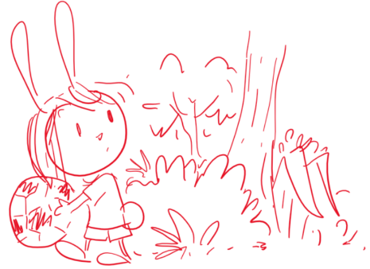
Elinor volunteers to get the ball (“I’ll get it!”) and runs into the trees, hopping over the bench. She looks for the ball for a beat, then she calls back to Ari and Hazel “Where did the ball go?” Ari responds that he saw it land near one of the plants. “One of the plants? Which plant?” Elinor asks. There are all kinds of plants here! There are big plants, and little ones, and medium sized ones… There are trees, and bushes, and vines and flower plants… There are ALL KINDS of plants here! As she says this, you can see that her curiosity gets piqued, and she gets distracted at the thought of so many different plants living together in one place. She’s about to explore this further when Hazel calls out to her that she saw the ball go near the tall tree. Elinor snaps out of it and grabs the ball and runs out to play.

Out in the field, Ms. Mole is starting to organize the kids. Ok, who’s ready to practice? Elinor is very excited to run and play: I am! Ok, says Ms. Mole, let’s do some drills! First, the kids line up and, at Ms. Mole’s signal, they race across the field. Elinor, Hazel and Ari run as fast as they can, but then Silas Cheetah blows past them (he’s really fast!). “Wow!” they think.

Next, the kids do some dribbling of the ball. Elinor dribbles the ball with some difficulty, and it gets away from her. Hazel dribbles the ball super slow and cautiously. Just then, Tito Mouse scurries past them, mastering the ball and doing zig-zags in a super agile way. “Cool!” they think. Ari tries to dribble the ball but ends up with the ball in his hands again, earning him a whistle blow from Ms. Mole.

Next, The kids line up to kick the ball. Elinor and Hazel wind up and kick their balls as hard as they can and the balls land reasonably far. Ari tries it and goofs it up comically. Then Sally Beaver steps up. She winds up and with a twist of her body she whacks the ball with her big tail and it goes really far. “Wow!” think the kids.

Next, the kids try keeping the ball up with their knees. Elinor and Ari struggle and each lose their ball. They turn and are surprised to see that Hazel is amazing at juggling the ball with her trunk. Hazel is very excited and shrugs to say “Who knew? The rules don’t say you can’t use your nose!”.

Coming out of the series of exercises, Elinor and Ari, a little winded, go to sit at the bench. They look a little sad. (Not super sad, just a little deflated by Elinor and Ari standards).

Just then, Ms. Mole sees them from the field and comes over to talk to them. “What’s the matter, soccer stars?“ she asks them. Elinor sighs. They explain they are really excited about playing, but they’re not good at running like Silas, or at dribbling with the ball like Tito, or at kicking the ball like Sally, or at keeping the ball up like Hazel. Yeah, says Ari, maybe we shouldn’t be playing soccer.
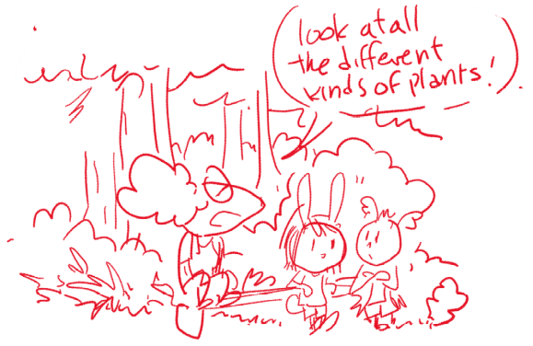
Ms. Mole takes it all in, and says, “Hmm, I see…” She thinks about it for a second, then has an idea. She says, “You know… I never noticed this cluster of trees here before.” Ari and Elinor still seem a little in their funk. Ms. Mole continues: “Look at all the different kinds of plants!” At this, Elinor’s ears perk up a little. “I wonder…” says Ms. Mole, “Why are there so many different kinds?” Elinor’s curiosity is awakened. “I know! That is SO INTERESTING!” She says. “I noticed that too! There are tall trees, and short trees, and bushes and grass and vines… Why are there SO many different kinds?” Ari also starts to get into it. “Yeah,” he says, “Why isn’t there just ONE kind of plant?”

That’s a great question, curious players! Says Ms. Mole. Elinor thinks for a second. “If there was only one kind of plant, like a big tall tree…” she says… A thought bubble forms near her. In the bubble, we see a big tall tree. “There would still be lots of room for other kinds of plants!” We see that in the space under the big tree other plants can grow: smaller trees, small plants and bushes and vines.

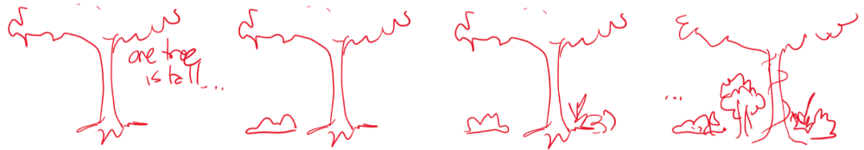

That’s right, says Ms. Mole. Each plant is different and each is good at growing in its own special way. When they’re all doing their best, the forest grows and becomes a place for all kinds of plants and animals. Elinor looks back at all the kids playing soccer, and she looks back at the cluster of trees. “I understand Ms. Mole! There’s plenty of room for everyone to be good at different things! The important thing is to do your best!” She looks around and as the beat of the ditty starts, she says, “We need more observations!”

Some trees are really tall,
And some kids are really quick!
And some plants are really small,
And some kids can really kick!

Ring-a-ding-ding it's great to sing
of Different Things and what they bring!
There’s lots of room for all!
Whether you’re tall or small!

Ring-a-ding-ding it's great to sing
of Different Things and what they bring!
There’s always room for you!
No matter what you can do!

While they’re singing, they revisit the forest and the kids playing soccer. At the end, they grab the ball and are excited to go play again. “Let’s go play!”

Ms. Mole starts the soccer game, and the kids scramble around at the ball. Silas Cheetah runs really fast to get the ball. Sally Beaver gives the ball a big tail kick. All the while, Elinor and Ari and Hazel are happy running around going after the ball and occasionally getting to hit it. They’re having fun! Suddenly, Hazel gets the ball and bops it with her trunk, up and over most kids. Elinor sees it go up and take a biiiiig hop and bounces the ball back with her ears. When she lands, her friends all cheer! Elinor is really good at hopping! But then Tito Mouse takes the ball and scurries toward the goal! Uh oh! He kicks it towards the goal and… Ari stops it by grabbing the ball. Ah! He drops it right away. Sorry, Ms. Mole!

Ms. Mole explains that it’s ok. That’s what you are good at Ari, you can be the goalie! Goalies can use their hands!

Song reprise:

Ring-a-ding-ding it's great to sing
of Different Things and what they bring!
There’s always room for you!
No matter what you can do!

Ms. Mole ends the soccer practice. Ok, who wants some lemonade? Yaaay! As the kids leave, Ms. Mole does an impressive sequence of ball maneuvers and kicks, winking at the camera as we...

IRIS OUT.

THE END.

Sara Sweetman Notes:

I really like the changes to this outline. The focus on how the characters each have unique skills is great. Really that is enough content at this age that for learning sake you would not need to add in the plant diversity. But I do think Ms/ Mole's goal to teach a lesson...to look around and see how plants and animals are different and somehow they all exist together in the world is a great lesson...then having Elinor realize she is different too but that is good because she can jump. It would be great if the song could more specifically capture the idea...that Ms. Mole and class NOTICE (use word if possible) similarities and differences in the plants and animals around them. The grass and the vine are both green plants but the grass is short and the vine grows tall to reach the sun.... The tree is strong and big whereas the (flower) is small and delicate.
I think LS8 is the right connection for this. You can take my note off on the connections because I was just trying to follow the logic of the story but as noted in this draft it needed to be simplified.

