J & D Notes:
Overall, there are some very nice moments in the original outline (copied below) However, we feel some elements are a bit mixed up and need clarifying. A few elements seem a bit mis-aligned with the core lesson:

- If the core lesson is supposed to be about diversity, we feel this outlines gets a little lost in the weeds talking about form and function, and the idea of being "good" at something. But being good at something is not really necessary for diversity. So we feel the lesson and the story are not connecting as well as it could.

- The emphasis on team and working together seems a bit mis-aligned –Plants in general are not working together, they are competing and have each found a niche that works for them. Another slight disconnect.

- The reveal of Elinor’s special skill of noticing things felt a bit difficult to grasp for little kids, especially because all the other skills were physical, while this one was non-physical. We want the kids at home to draw parallels between the plant example and what’s happening in Elinor’s world, so let’s make that as simple as possible.

- We felt it was a bit of a stretch for our kids to figure out the main lesson on their own. We think they need some assistance to arrive at the right conclusion here.

Below is a rough version of the outline that we think aligns things a little better.

Elinor's Question: Why are there so many different kinds of plants?
Logline: As Elinor searches for her role on the soccer team, she notices that there are many different kinds of plants in the forest and realizes there can be many different kind of soccer players too.

Curriculum Goals: SARA PLEASE CHECK! These have not been revised.
LS8. - Begin to understand that there are many different kinds of living things and how they may be the same or different. Sara’s clarification: Diversity of Life: Different living things have different characteristics that allow them to function in their environment. It's a good thing we all don't have all the same form and function because then we could not have a healthy system. Elinor notices how the diversity of plants in the forest and how their forms and functions help other plants. Then she relates this observation to the different soccer skills of her friends and how that diversity helps her soccer team.
SEP7. Engaging in argument from evidence: a. Engage in discussions before, during, and after investigations. b. Support thinking and argue ideas with evidence.

1.EXT. SOCCER FIELD BORDERING FOREST – DAY
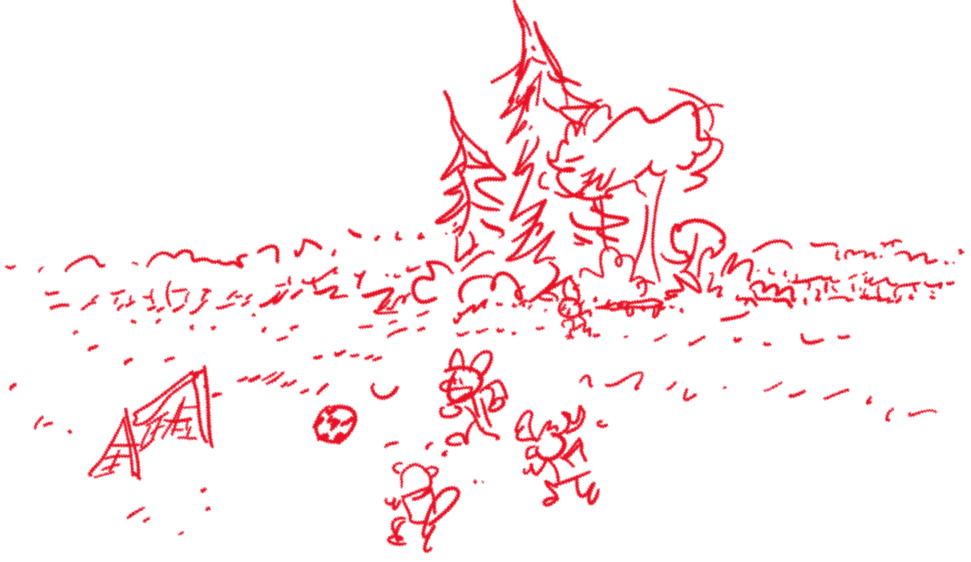
MS. MOLE leads Elinor's CLASSMATES - HAZEL, ARI, SALLY BEAVER, SILAS CHEETAH, TITO MOUSE, and the GOAT TWINS - out into a field near the school, holding a SOCCER BALL. "Let’s play soccer!", Ms. Mole bellows, and she kicks the ball - quite far! Some of the kids race after it as a group. Elinor, Hazel and Ari stay behind, each with their own ball. Elinor says she is SO EXCITED ABOUT running and playing and kicking the ball. Hazel is less sure she’ll do well, and Ari, with his usual bravado, tries a few moves, only to slip on the ball and have it land (gently) on his head.

Ms. Mole calls out to them to gather around, and the kids regroup around her. Ms. Mole explains that soccer is a game that you play with a ball in all kinds of different ways, but you can't use your hands, she adds, unless you're the goalie. "I'll show you," Ms. Mole says, and asks for Elinor’s ball. Ms. Mole does some fancy footwork as she explains that most times you use your feet to kick or pass the ball. Then she hoofs it again! It flies over the kids, bounces off the goalpost, and returns to Ms. Mole as if that was her intention. Whooooooa. Ari asides to Hazel, impressed: "Ms. Mole is a soccer star – who knew?!" But remember, Ms. Mole says, the most important thing is to have fun and do your best.

Ms. Mole starts passing balls to various kids. Each kid scrambles to get the ball that was meant for them and then goes off into the field to play. When Ari gets his pass, he does a quick swoop through the air and grabs the ball. Ms. Mole calls out: "Remember, Ari! No hands!” Ari looks down at the ball in his hands, shocked at the realization that he's holding it. He drops it like a hot potato! "Ahh! How did that get there? Sorry!" He winds up to kick the ball, but his kick goes wild and the ball goes off into a nearby cluster of trees and plants that sits behind a sideline bench made out of logs.

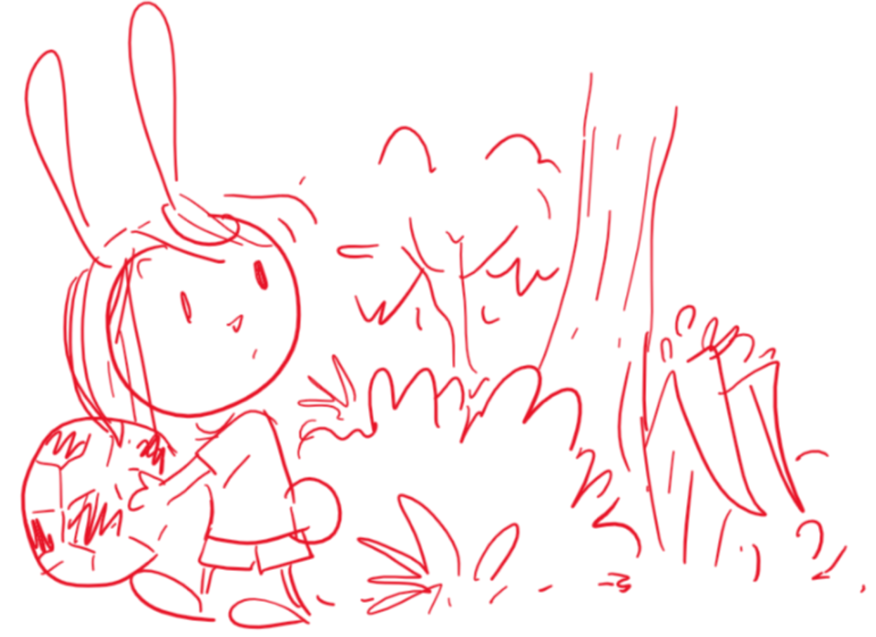
Elinor volunteers to get the ball (“I’ll get it!”) and runs into the trees, hopping over the bench. She looks for the ball for a beat, then she calls back to Ari and Hazel “Where did the ball go?” Ari responds that he saw it land near one of the plants. “One of the plants? Which plant?” Elinor asks. There are all kinds of plants here! There are big plants, and little ones, and medium sized ones… There are trees, and bushes, and vines and flower plants… There are ALL KINDS of plants here! As she says this, you can see that her curiosity gets piqued, and she gets distracted at the thought of so many different plants living together in one place. She’s about to explore this further when Hazel calls out to her that she saw the ball go near the tall tree. Elinor snaps out of it and grabs the ball and runs out to play.

Out in the field, Ms. Mole is starting to organize the kids. Ok, who’s ready to practice? Elinor is very excited to run and play: I am! Ok, says Ms. Mole, let’s do some drills! First, the kids line up and, at Ms. Mole’s signal, they race across the field. Elinor, Hazel and Ari run as fast as they can, but then Silas Cheetah blows past them (he’s really fast!). “Wow!” they think.

Next, the kids do some dribbling of the ball. Elinor dribbles the ball with some difficulty, and it gets away from her. Hazel dribbles the ball super slow and cautiously. Just then, Tito Mouse scurries past them, mastering the ball and doing zig-zags in a super agile way. “Cool!” they think. Ari tries to dribble the ball but ends up with the ball in his hands again, earning him a whistle blow from Ms. Mole.

Next, The kids line up to kick the ball. Elinor and Hazel wind up and kick their balls as hard as they can and the balls land reasonably far. Ari tries it and goofs it up comically. Then Sally Beaver steps up. She winds up and with a twist of her body she whacks the ball with her big tail and it goes really far. “Wow!” think the kids.

Next, the kids try keeping the ball up with their knees. Elinor and Ari struggle and each lose their ball. They turn and are surprised to see that Hazel is amazing at juggling the ball with her trunk. Hazel is very excited and shrugs to say “Who knew? The rules don’t say you can’t use your nose!”.

Coming out of the series of exercises, Elinor and Ari, a little winded, go to sit at the bench. They look a little sad. (Not super sad, just a little deflated by Elinor and Ari standards).

Just then, Ms. Mole sees them from the field and comes over to talk to them. “What’s the matter, soccer stars?“ she asks them. Elinor sighs. They explain they are really excited about playing, but they’re not good at running like Silas, or at dribbling with the ball like Tito, or at kicking the ball like Sally, or at keeping the ball up like Hazel. Yeah, says Ari, maybe we shouldn’t be playing soccer.
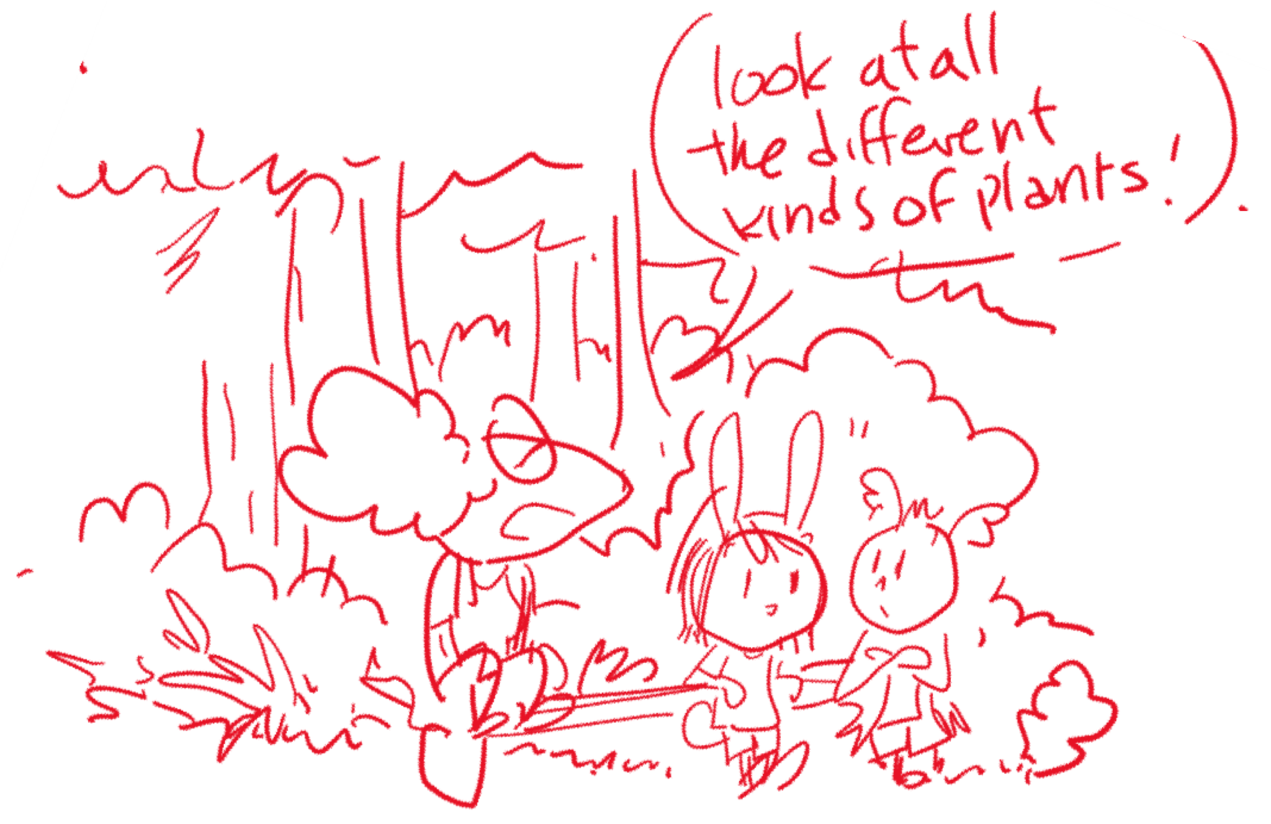
Ms. Mole takes it all in, and says, “Hmm, I see…” She thinks about it for a second, then has an idea. She says, “You know… I never noticed this cluster of trees here before.” Ari and Elinor still seem a little in their funk. Ms. Mole continues: “Look at all the different kinds of plants!” At this, Elinor’s ears perk up a little. “I wonder…” says Ms. Mole, “Why are there so many different kinds?” Elinor’s curiosity is awakened. “I know! That is SO INTERESTING!” She says. “I noticed that too! There are tall trees, and short trees, and bushes and grass and vines… Why are there SO many different kinds?” Ari also starts to get into it. “Yeah,” he says, “Why isn’t there just ONE kind of plant?”

That’s a great question, curious players! Says Ms. Mole. Elinor thinks for a second. “If there was only one kind of plant, like a big tall tree…” she says… A thought bubble forms near her. In the bubble, we see a big tall tree. “There would still be lots of room for other kinds of plants!” We see that in the space under the big tree other plants can grow: smaller trees, small plants and bushes and vines.

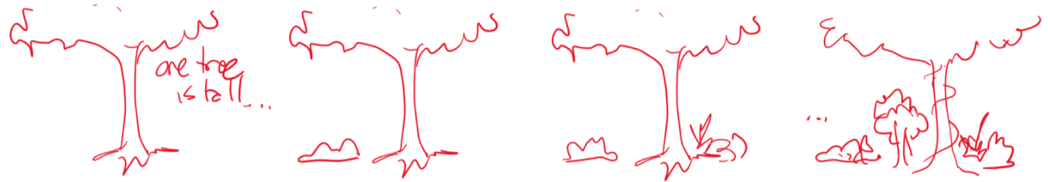

That’s right, says Ms. Mole. Each plant is different and each is good at growing in its own special way. When they’re all doing their best, the forest grows and becomes a place for all kinds of plants and animals. Elinor looks back at all the kids playing soccer, and she looks back at the cluster of trees. “I understand Ms. Mole! There’s plenty of room for everyone to be good at different things! The important thing is to do your best!” She looks around and as the beat of the ditty starts, she says, “We need more observations!”

Some trees are really tall,
And some kids are really quick!
And some plants are really small,
And some kids can really kick!

Ring-a-ding-ding it's great to sing
of Different Things and what they bring!
There’s lots of room for all!
Whether you’re tall or small!

Ring-a-ding-ding it's great to sing
of Different Things and what they bring!
There’s always room for you!
No matter what you can do!

While they’re singing, they revisit the forest and the kids playing soccer. At the end, they grab the ball and are excited to go play again. “Let’s go play!”

Ms. Mole starts the soccer game, and the kids scramble around at the ball. Silas Cheetah runs really fast to get the ball. Sally Beaver gives the ball a big tail kick. All the while, Elinor and Ari and Hazel are happy running around going after the ball and occasionally getting to hit it. They’re having fun! Suddenly, Hazel gets the ball and bops it with her trunk, up and over most kids. Elinor sees it go up and take a biiiiig hop and bounces the ball back with her ears. When she lands, her friends all cheer! Elinor is really good at hopping! But then Tito Mouse takes the ball and scurries toward the goal! Uh oh! He kicks it towards the goal and… Ari stops it by grabbing the ball. Ah! He drops it right away. Sorry, Ms. Mole!

Ms. Mole explains that it’s ok. That’s what you are good at Ari, you can be the goalie! Goalies can use their hands!

Song reprise:

Ring-a-ding-ding it's great to sing
of Different Things and what they bring!
There’s always room for you!
No matter what you can do!

Ms. Mole ends the soccer practice. Ok, who wants some lemonade? Yaaay! As the kids leave, Ms. Mole does an impressive sequence of ball maneuvers and kicks, winking at the camera as we...

IRIS OUT.

THE END.

ORIGINAL OUTLINE
ELINOR'S TOWN
EP 109 Why Are There So Many Different Kinds of Plants?
By: Dave Dias
OUTLINE V1 - December 18, 2018
Elinor's Question: Why are there so many different kinds of plants?
Logline: As Elinor and her class explore playing soccer, her observations about how forest plants do different things that work together to help protect a strawberry patch, make Elinor see how she and her friends have different skills that work together to help them play soccer.
Curriculum Goals:
LS8. - Begin to understand that there are many different kinds of living things and how they may be the same or different. Sara’s clarification: Diversity of Life: Different living things have different characteristics that allow them to function in their environment. It's a good thing we all don't have all the same form and function because then we could not have a healthy system. Elinor notices how the diversity of plants in the forest and how their forms and functions help other plants. Then she relates this observation to the different soccer skills of her friends and how that diversity helps her soccer team.
SEP7. Engaging in argument from evidence: a. Engage in discussions before, during, and after investigations. b. Support thinking and argue ideas with evidence.

1.EXT. SCHOOL - DAY

MS. MOLE leads Elinor's CLASSMATES - HAZEL, ARI, SALLY BEAVER, SILAS CHEETAH, and the GOAT TWINS - out of the school, with a SOCCER BALL at her feet, ready to be kicked. "To the soccer field", Ms. Mole bellows, and she hoofs the ball - quite far! The class races after it as a group.

Elinor drags a MESH BAG OF OTHER SOCCER BALLS out the door. Ms. Mole thanks her for volunteering to bring them to the field. Elinor stops walking as she sees MS. DUCK and her THREE DUCKLINGS who race to follow their mama down the sidewalk. Elinor glances to her classmates pursuing the soccer ball like a herd. She giggles; her friends running in a group look like Ms. Duck's ducklings following their Mama! Ms. Mole is amused by the comparison: "Hee hee, yes they do, good observation, Elinor!"

2.EXT. SOCCER FIELD BORDERING FOREST - MOMENTS LATER

With Elinor dragging the bag of soccer balls alongside her, Ms. Mole arrives at the soccer field to greet Elinor's classmates, who are all still herd-chasing the first ball around wildly. Ms. Mole calls out to them that they're going to play some soccer today, and the kids regroup around her.
Ms. Mole explains that soccer is a game where that you play with a ball that you can move in all kinds of different ways with different parts of your body, but you can't use your hands, she adds, unless you're the goalie.

Elinor is intrigued. "This is really interesting! How does that even work?" "I'll show you," Ms. Mole responds. Elinor gives her a ball. Ms. Mole does some fancy footwork as she explains that most times you use your feet to kick or pass the ball. Then she hoops it again! It flies over the kids, bounces off the goalpost, and returns to Ms. Mole as if that was her intention. Whooooooa. Ari asides to Hazel, impressed: "Ms. Mole is a soccer star – who knew?!"

Ms. Mole starts passing balls to various kids, but her aim is off each time. Each kid scrambles to get the ball that was meant for them. When Ari gets his pass, he kicks it back to Ms. Mole -- who surprises him again by leaping up and using her leg to knock the ball down. Ooohs and awes from the class. "Your body has lots of different parts," Ms. Mole says. "And in soccer, you can use almost all of them to move or stop the ball!"

"You mean, I can do this," Ari asks, lobbing a ball upward and bum-bopping it... only to have the ball not go far at all. "Okay, maybe that part's not the best way to move the ball..." Everyone giggles. "Use whatever body parts you like," Ms. Mole says. "Except your hands, only the goalie can use their hands. And don't use your heads either, if you please."

Elinor is wowed. "I didn't realize there was so much to playing soccer!" Ms. Mole tells the class that they don't have to learn everything about soccer all at once today. They’re just trying to find out what they're good at, and practice that. "We're all different and good at different things, and it's a good thing too, because that's what makes a good soccer team." Time for everyone to give a bunch of different soccer moves a try!

3.EXT. SOCCER FIELD BORDERING FOREST - ACTIVITIES - CONTINUOUS

The kids spread out to try different soccer actions. Elinor, Ari, and Hazel watch their classmates try some kicking, passing, running, etc., before they spot a free ball and the trio all run for it at once. Ari's the last to reach it. "Aww, too bad you can't fly in soccer," he says. "I'm a much faster flier than I am a runner!" He does a quick swoop through the air to make his point and grabs the ball. Ms. Mole calls out: "Remember, Ari! No hands!” Ari looks down at the ball in his hands, shocked at the realization that he's holding it. He drops it like a hot potato! "Ahh! How did that get there?"

Elinor, Ari and Hazel pass the ball to each other. Hazel returns a pass with her trunk! Elinor’s impressed. "Wow, you pass the you have perfect aim, Hazel, even when you use your trunk!!" Hazel blushes. Elinor's passes however, go off the mark. Ari misses his pass too, and he does backflips to catch up to it, to many giggles. He picks up the ball again -- and Ms. Mole calls him out again about not doing that! Ari drops the ball and scowls at his hands: "Bad hands, don't grab the ball!"

As Hazel keeps practicing her "trunk bopping", Ari and Elinor are almost blown away by Silas Cheetah racing past at lightning speed, kicking a ball ahead of her. "Wow, those are some speedy legs you've got, Silas!" But Silas is almost at the far other end of the field by that point: "What, Elinor? I can't hear you from over here!" Elinor and Ari giggle.

Elinor observes more fun soccer actions from classmates: Sally Beaver uses her tail to 'tail-kick' the ball, all the way to the far end of the field -- nice! She sees Ms. Mole watching the Goat Twins throwing and passing the ball with their horns. "Very clever, girls! Using your horns is different than using your head, that's perfectly allowed! Keep it up!"

Elinor is determined to find a soccer skill she's really good at, and so is Ari. Having watched the others trying different things, she knows her legs can't run as fast as Silas, and she can't tail-kick the ball as far as Sally, who has the perfect tail for it! But when Elinor sees the Goat Twins passing the ball again, Elinor perks up. She has long ears... maybe she can move the ball like that using them!

With Ari's help, Elinor tries to 'throw' the ball with her ears, a la the Goat Twins. But each time she tries, the ball gets tangled in her ears as she tries to throw or catch, and the ball goes careening away. Ari flies over and instinctively picks up the ball again. "ARI, NO HANDS!!" bellows Ms. Mole!

Startled, “WHOOAA!” Ari accidentally hurtles the ball into the nearby FOREST surrounding the soccer field. Ari glares at his hands: "Hands, you've been nothing but trouble for me today."

Elinor laugh “Come on Ari! We’ll never get good at soccer if we don’t have a ball!” She runs off searching and Ari follows.

4.EXT. FOREST – MOMENTS LATER

As Elinor and Ari search for the ball, Ari is getting concerned. "Elinor, what if you and I never find out what we're good at?" But Elinor's confident, she knows the answer is out there, they just have to keep searching!

Suddenly they come to a WILD STRAWBERRY PATCH. Ohhh, so pretty and red! But Ari's more focused on looking for the black and white soccer ball – and there it IS!

ANGLEON: the ball, which came to rest in some TALL GRASSES near LOW BUSH near the strawberries.

"Whew, those strawberries got lucky, huh?" says Ari. "If that grass didn't stop the ball, they'd be strawberry jam!" Ari grabs the ball and is about to head back to the soccer field... when he sees Elinor kneeling down to eye the strawberries closely and run her hand through the tall grasses that blocked the ball.

SCIENCE MOMENT CU: Elinor marvels at how the grass, just by growing this tall, helped the strawberries not to get squished.

Elinor is in full discovery mode: "Plants helping other plants, just by doing what they do best? This is SOOOO interesting! We need MORE observations!" She examines the VINES around the berries. They keep the strawberries together. Nice!

Elinor then notes the BUSHES beside the tall grass. "These bushes are low, so they don't hog all the sunlight – and that helps the strawberries grow! What good neighbors"

BACK ON: Ari reminds Elinor that they should get back to the field - still need to find what they're good at in soccer.

"Don't worry Ari, we will," says Elinor, smiling confidently. “All these different plants help the strawberry patch, just like all of us have something we can do for the soccer team!”

With at Elinor starts to sing, pointing to the plants she’s just observed as she does.
SONG: "DIFFERENT THINGS"
ELINOR (singing):
Ring-a-ding-ding it's great to sing
of Different Things and what they bring!

ELINOR (singing):
All of these different plants
Give the strawberry patch a chance
The grasses help to hide them
The vines they help protect them
The shrubs let sunshine through
Impressed, Ari sings the chorus along with Elinor:
ELINOR & ARI (singing):
Ring-a-ding-ding it's great to sing
of Different Things and what they bring!

Elinor leads Ari from the forest back toward the soccer field. "I KNOW we’re both good at something - we just have to find it! C'mon!"

5.EXT. SOCCER FIELD BORDERING FOREST – MOMENTS LATER

Returning to the soccer field, Elinor points out to Ari their various classmates who are still spread out doing different soccer actions. Elinor begins the SONG REPRISE, showing Ari the different soccer actions their friends are doing well:

SONG: DIFFERENT THINGS (REPRISE)
ELINOR (singing):
Ring-a-ding-ding it's great to sing
of Different Things and what they bring!
ELINOR (singing):
All our different skills
Make playing soccer a thrill!
Hazel's great at trunk-bopping
Silas is super-fast!
Sally's good at tail-kicking
The Goats use horns to pass!
Each friend that Elinor points out in song, is pleased by Elinor's compliment, and to hear that they really are good at those things! Together the kids all reprise the final chorus:
ELINOR, ARI, HAZEL, MEDHI, SALLY, GOAT TWINS (singing):
Ring-a-ding-ding it's great to sing
of Different Things and what they bring!

SONG ENDS.

6. EXT. SOCCER FIELD BORDERING FOREST - CONTINUOUS

Ari is happy that everyone else knows what they're good at in soccer, but what about them?! "What are you good at Elinor," he asks? Elinor is stumped. She's been so busy watching her friends that she knows what they're good at... but not herself yet.

"I know what you're good at," declares Hazel with confidence "--noticing things!" Ms. Mole smiles. "Very true, Hazel. I agree! Elinor is VERY good at noticing things, especially about her friends" Ms. Mole turns to Elinor: "Would you like to be the team's Coach?" Elinor goes wide-eyed with surprise. "Me? Be our Coach? Really?" "Yes," says Ms. Mole. "Because that's what coaches do. They observe, they notice things, and then they help their players improve." Elinor proudly accepts! WOW!

"But what about me?" Ari asks, doing a little flip in the air. "Any place for a bat with big wide wings who can't keep his feet on the ground or his hands off the ball?" Elinor smiles. "I know the perfect place for you..." Elinor runs up to a nearby soccer ball and hoofs it. The ball goes high in the air toward Ari -- who instinctively jumps and flutters his wings to make a spectacular, dynamic catch with his hands. Elinor finishes: "...you should be the GOALIE!"

Ms. Mole heartily agrees! The class erupts in <CHEERS!>, and the friends resume playing with the various soccer balls, running and kicking them about. And in Elinor's case, coaching Ari at the net, gesturing with goalie motions that he eagerly mimics.

IRIS OUT.

THE END.

