ELINOR’S TOWN
Owl-Girl
PREMISE P040 – V5V5 – November 166, 2018
Jorge Cham and Daniel Whiteson

Elinor’s Question: Why do owls sleep during the day?
Logline: Elinor learns that some animals have a different schedule.
Curriculum Goals:
- LS2 Begin to explore how different external features of an animal help it survive in its environment
- ND1. (RTL Crosscutting concept ‘Patterns’): Begin to understand how patterns of day and night contribute to structure and function in nature. Because the owl is awake at night it has specific characteristics to help it survive in its unique habitat.
- SEP2: Developing and using models
- SEP8 Obtaining, evaluating and communicating information
  - Obtain information through discussing prior knowledge and observations with experts including teachers or knowledgeable adults
  - Use basic science and engineering content vocabulary when investigating and describing observable phenomena
  - Share findings and explanations (correct or incorrect) through a variety of methods

Elinor and her friends are on a walk after school. The kids are discussing what they are going to dress up as for class costume day. Hazel wants to go as something she really loves, Ari wants to go as something cool, and Elinor – she’s not sure, but it has to be something INTERESTING. While they talk, Elinor spots an owl in a tree in the forest, sitting calmly with its eyes closed. Ari flies up to get a better look and thinks it might be sleeping. She thinks it’s beautiful and wants to see what it looks like with its wings open and flying, but it looks like it’s asleep. Elinor and her friends wait for a while to see if it’ll wake up, but it doesn’t. They wonder, do owls sleep ALL the time?? So, they walk on.

That night, Elinor is awakened by a strange sound coming from outside. Someone seems to be yelling “Whooo!”!” Elinor tries to respond: “Who what?” The voice answers back, “Whoo!” Elinor gets a little annoyed: “Yes, I know you said who! Do you mean me? I’m Elinor!” She decides to wake her mom up and asks her to get more observations with her. They go outside to find it, and Elinor is surprised at how many things are happening at night. They see insects flying around, and some nocturnal birds and lizards. They bump into a few characters, like Ari’s father and Mr. Racoon, who says that he’s on his way to work at the bakery. Elinor asks why now, in the middle of the night and he explains that some jobs are best done at night, so that the bakery treats are fresh for breakfast. They hear the “who” sound again and they look up: they spot the owl, but it’s not in the tree, it’s soaring in the sky beautifully. They see it glide and flap its wings super-silently, which Elinor thinks is very cool. They see it grab something from the ground and land in a tree and say “Whoo!” Elinor sees that the owl is awake at night. Elinor’s mother explains that they have special parts that help them live at night.
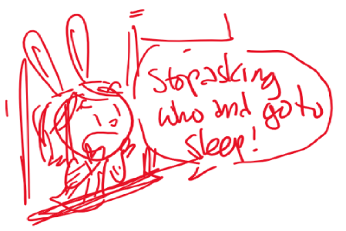
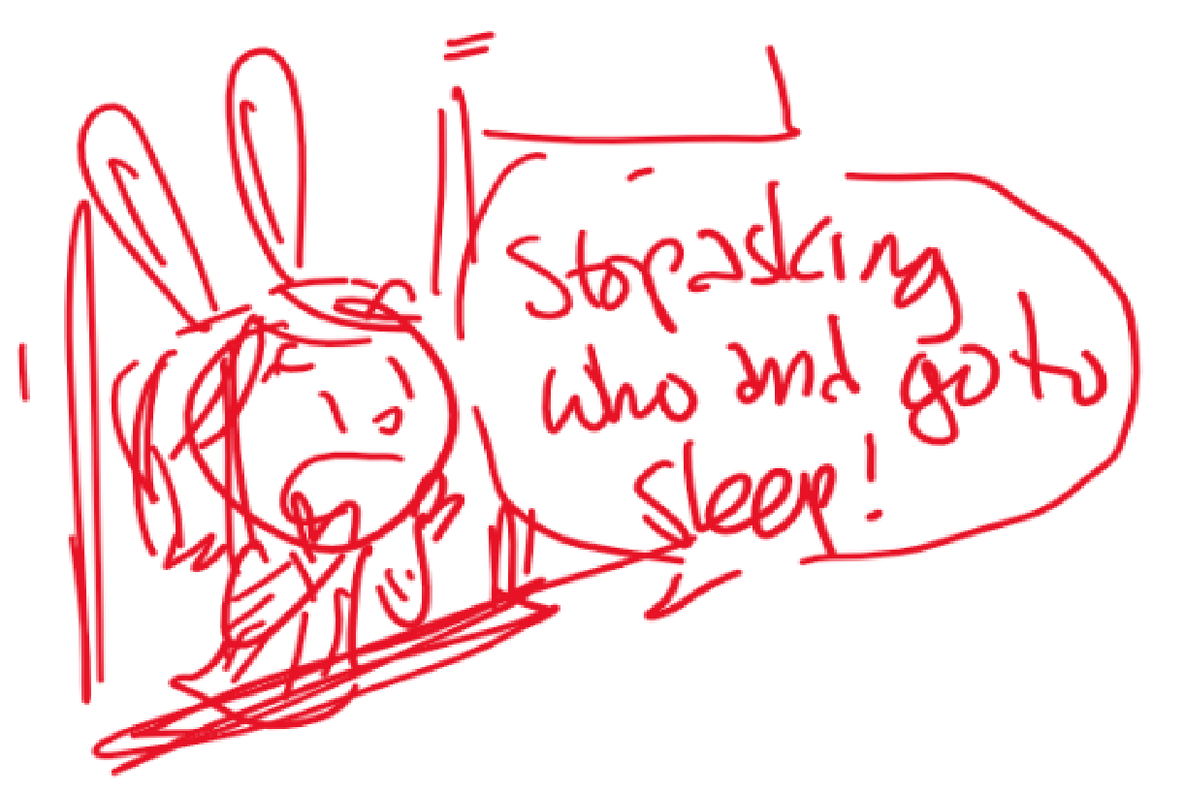
They have super special eyes to spot bugs and special feathers that are super quiet when they fly to help them catch bugs. Elinor says she knows exactly what she wants to be for the costume parade.

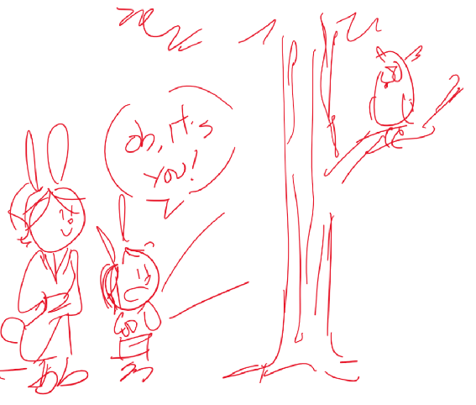
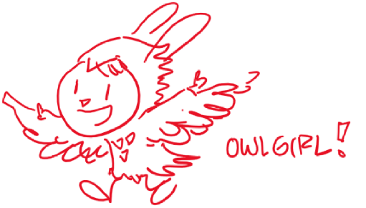
At school the next day, it’s costume day and everyone is dressed as something they find cool. Hazel is dressed like a self-reading book (the trunk turns the pages), while Ari is dressed like Super Ninja Bat, his favorite superhero. Elinor surprises everyone by appearing in an owl costume! She says she had to stay up super late making the costume, but she’s really happy because owls have super vision and can fly really quietly and she explains how these special parts help them live at night. When it’s time for each kid to stand up and talk about their costume, and it’s Elinor’s turn, Ari stands up instead. He explains that, like the owl, Elinor was awake too much at night, and is now taking a nap.
