ELINOR’S TOWN
EP 103 Owl-Girl
By: Jorge Cham and Daniel Whiteson
OUTLINE – Nov 26, 2018

Elinor’s Question: Why do owls sleep during the day?
Logline: Elinor learns that some animals have a different schedule.
Curriculum Goals:
- LS2 Begin to explore how different external features of an animal help it survive in its environment. Elinor learns that an Owl has certain characteristics that help it survive at night.
- SEP2: Developing and using models
- SEP8 Obtaining, evaluating and communicating information
  - Obtain information through discussing prior knowledge and observations with experts including teachers or knowledgeable adults
  - Use basic science and engineering content vocabulary when investigating and describing observable phenomena
  - Share findings and explanations (correct or incorrect) through a variety of methods

1. EXT FOREST -- DAY

Open on ELINOR looking closely at a flower. She’s poking around and lifts a small rock. She is curiously looking for something. Widen out to show HAZEL and ARI waiting for her. “Come on Elinor, you can’t look at EVERYTHING in the forest.” Elinor calls back, “Ok, I’m going!” She bounces ahead of them, looking at something else she spots. She is very energetic and silly, scrambling under a low branch, kicking off a tree trunk in her enthusiasm. Hazel and Ari look at each other and follow.

As they walk, Hazel says that she can’t wait for tomorrow at school. Ari asks why and Hazel reminds him that tomorrow is the class costume parade, and that she has been planning her costume for weeks. Ari remembers now and is also enthusiastic. He says that he has a fun idea for a costume too, and that it is going to be “super cool and amazing”. Hazel is encouraging. “I’m sure it will be. I remember last year you were a baseball and bat.” Hazel comments that she wants to dress up like something that she really likes. Ari says: “Like peanut butter cookies?” Hazel laughs and says “No, you’ll see! But I do love PB cookies. Maybe next year!”

As they chat, Elinor has been keeping up but going back and forth, up and down, looking at lots of different places. She looks under bushes, in the trees, etc. She has snuck between them, hopped over them, or they have had to go around her while her head is stuck in a bush.

They come to a small clearing. Ari and Hazel get Elinor’s attention and ask her what SHE is planning to be for the costume parade. Elinor stops and gives a big siiigh. She says she’s not sure what she wants to be for costume day! She wants it to be something REALLY INTERESTING, but she doesn’t know what! She’s been looking ALL over the place for ideas, but she hasn’t found the right idea yet!

Ari and Hazel offer to help her look. They join Elinor and look in a few specific places (that we will revisit later). They look under a bush, they check out a specific tree trunk. Ari flies up and they look up at the branches in a tree.

After a beat of looking, the kids talk again. Hazel says, “There doesn’t seem to be a lot going on in the forest today…” Elinor scratches her head, looking around for other places to look. Ari, sitting up in the tree branch, says “Hey! I’ll look from up here!” and makes a show of looking down from the branch, searching for something interesting. Elinor looks up at him and says: “Whoa Ari! There’s something RIGHT ABOVE YOU.” We see that one branch higher in the same tree is an owl! It’s sitting there looking majestic but with its eyes closed. Ari is totally surprised (but not scared?) and flutters down.

The kids admire it for a few moments quietly and then wonder why it’s so STILL? What is it doing? Why isn’t it doing anything? Elinor stands on Hazel’s shoulders to get a look, but can’t get high enough. Ari flies up cautiously to get a closer look and reports that the owl’s eyes are closed. Maybe it’s sleeping? Elinor is especially transfixed and says they should wait for it to finish its nap because she wants to see it flying. She wonders what it looks like with its wings open, pantomiming an owl.

They pause again and look up, waiting for the owl to wake at any moment. Nothing happens. They sit, doing their best to be patient. Hazel has her book ready to take notes, Elinor has her eyes fixed on the owl, and Ari has unpacked a snack. He crunches loudly on something and both Elinor and Hazel give him a hairy eyeball. He says: “What? Maybe it will help it wake up.”

They keep looking for a moment, but quickly get fidgety; Ari continues to crunch on his loud snack; Elinor and Hazel cringe each time. Elinor is getting impatient and wonders: “When is it going to wake up?” Hazel says: “It can’t sleep ALL day long… can it?” Ari says: “Sleep all day? That sounds pretty good to me! But… then when do they have time to eat?”

It’s clear the kids have a mystery. Why does the owl sleep so much during the day? But after speaking of eating, they realize it’s time to get home for dinner, so they walk on. Elinor takes one last look back, hoping to see the Owl awake.

2. INT. ELINOR’s BEDROOM -- NIGHT

Open on Elinor in bed. She is sleeping, but her arms and legs are moving a bit as if she’s having an active dream. She says in her sleep, “Wake up, owl… wake up…”

At that moment, we hear a loud but slightly muffled “Whooo” sound coming from outside her window. Elinor stirs a bit but doesn’t wake. We hear it again, and Elinor’s eyes open. We hear it a third time, this time she hears that it’s coming from outside. She rubs her eyes and hops out of bed and goes over to the window and opens it. The sound comes again, more clearly now. Elinor replies “Who what?” The sound comes again “Whoo.” Now, Elinor is a bit annoyed and sticks her head out of the window and yells: “Yes, I know you said who! Do you mean me? I’m Elinor!” The voice responds “Whoo” and Elinor says: “I just told you!” with obvious impatience.

She closes the window and goes into the next room, tiptoeing into her parents’ bedroom, where they are sleeping.

Elinor tugs on her mom’s sleeve and whispers really loudly, “Mom!” We see her mom wake up from a dream; her dad stays asleep. Elinor’s mom wakes up, rubs her eyes and says “What is it Elinor? Is everything OK?”
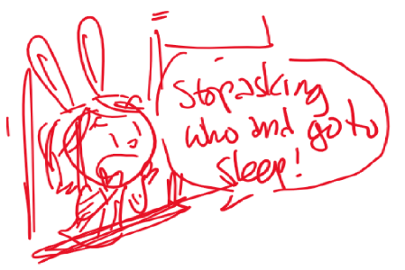
Elinor says that she can’t sleep. “Why not?” Because she has a QUESTION! She wants to know who is who-ing out her window and she needs MORE OBSERVATIONS. Since it’s night, she wants her mom to come with her. Her mom is charmed and says, “OK, let’s get our night-time observation kit!” They put on slippers, robes, and get two flashlights, leaving Elinor’s dad to sleep. We hear a muffled “whoo” from outside. Elinor hurries her mother along so that they don’t miss it.

3. EXT. ELINOR’s HOUSE -- NIGHT

They step out of the house. A light in the front of the house illuminates the door and immediate surroundings, but everything else nearby is dark. Elinor comments that she can’t see anything!

Elinor’s mother turns on their flashlights and they explore a bit, walking a little into the woods. Elinor’s flashlight finds a lizard that runs under a bush (the same bush as before), and then spots ants crawling up a tree trunk (the same tree trunk as before). They hear a rustle and spot a bird in a tree (the same tree branches as before). Elinor is amazed that there is so much going on at night! She sings as she explores:

I thought the forest was quiet at night
But now that I have my flashlight
I see birds and bugs and lizards, too!
But I still wonder who said “whooooo?”

Just then, they bump into Mr. Raccoon, who is as surprised to see them as they are to find him. Elinor asks him if he is ALSO out looking for the source of the mysterious “who”? He says: “You are looking for who?” Elinor’s mom says: “Yes.” He asks again, “Who?” Elinor says, “yes!” He asks again: “I mean WHO are you looking for?” They reply: “Yes, we are looking for the who!”

After a beat of confused looks (for humor), they ask him why HE is awake. He tells them that he is up at this time every night! Elinor is amazed and says: “Why are you awake at night?” He explains that he works at the bakery. She asks “Can’t you bake during the day?” He explains that if the tasty treats, like Elinor’s favorite carrot cake muffins, are going to be ready for breakfast, he has to start baking at night. She understands that some jobs are better done at night. She asks: ”But then when do you sleep?” He tells her that he sleeps during the afternoon while everyone else is up. He would love to chat more but “it’s time to make the donuts” and hurries off. “And the carrot cake muffins!” calls Elinor. After he leaves, Elinor tells her mom that she’s AMAZED at how many things are happening at night while she sleeps.

Just then, they hear the “who” sound again. They look up, searching for the source. Suddenly, they spot the owl soaring in the sky! It’s above the trees and it flies and banks with amazing grace and beauty. Most important, it flies SILENTLY. It turns and glides down to the ground, grabbing something before landing up in the tree and saying “Whoo!”

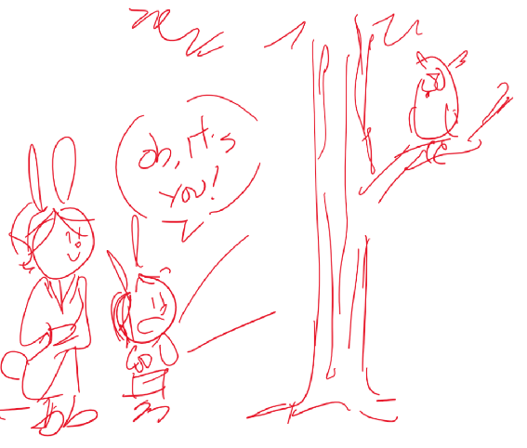
Elinor goes “Whooaaaaaa…” She whispers to her mother, excitedly, that it’s the owl she saw sleeping before. She pieces it together: it must have been sleeping during the day so it could be awake at night, just like the lizard, ants and Mr. Raccoon! Elinor wonders: why is it up at night? Elinor’s mother explains that it likes to eat food like bugs and worms that come out at night. Elinor asks how it can see them if it’s dark? Her mother explains that it has super special eyes that are good at seeing at night and that it also has special feathers in its wings that let it fly silently at night.

Elinor is clearly amazed and entranced by the Owl. She tells her mom she knows EXACTLY what she wants to be for the costume parade! As they walk back to the house, we hear the owl say “Who?” before we fade out.

4. INT. CLASSROOM -- DAY

Open on a bunch of children in costume talking excitedly, including Hazel and Ari, but not Elinor.

Hazel is dressed like a big book. She explains that her favorite thing to do is to read, but that she wishes she had a book that turned the pages for her, so she dressed up as one. She shows them how her trunk turns the pages. They all think that’s wonderful. One of the kids looks at the page that’s open and says: “Is that a recipe for peanut butter cookies? My favorite!”

Ari is dressed in all black, like SUPER NINJA BAT, his favorite superhero. He jumps up and does some cool ninja-like bat moves. Some fruit clumsily falls out of his pocket, and he snatches them up. “Hey, Ninjas get hungry too!”

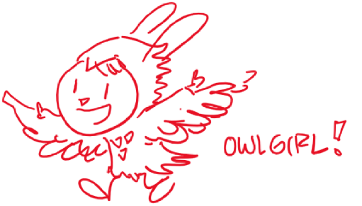
Elinor sneaks in silently, surprising everyone and dressed like an OWL. “Whooo!” she says! She explains that owls can fly really quietly, and have super good eyes for seeing at night. That lets them find their food. The kids all think it’s super cool. She yawns and explains that the only problem is that she had to stay up super late making the costume.

Ms. Mole calls the class to order. She is dressed as a SPY, with a trench coat, hat, sunglasses, a small spyglass and a notebook. She tells them she is dressed as a spy because she likes to listen carefully and write down what she learns. She opens her notebook and says: “Right now I can hear Ari eating something crunchy.”

We see Ari, mouth full. He is embarrassed for a moment but swallows his mouthful and says: “I wish I had special feathers to do that more quietly.”

Ms. Mole announces that it’s time for the parade. The kids start to line up but we don’t see Elinor. Ms. Mole asks everyone “Where is Elinor?”

Ari answers. He explains that, like the owl, Elinor was awake too much at night, and is now taking a nap. We see her curled up with her head tucked under a wing.

FIN!

