Pitches I had fundamental questions are MARKED IN YELLOW we can discuss.

The other pitches can go to the writers as you have written them, so they can read your original intentions. While the may not be perfect (SHOCKERS!!! No of COURSE they are perfect!! What am I saying??” they are all a good place to start.

I can add my notes “in the room” or later if appropriate – or not! But have a read so you can see my thinking (always with the thinking!!)

There are 24 pitches that are ready to go, so we are in good shape.

- “The tail end of the problem”

Science concept: animals have tails that suit their needs: balance, insects, swimming (adaptation)

Problem solved: they build insect-brushes modeled from horse-tails.

Synoposis: The kids are at out in the forest one day, having a picnic with their families. Unfortunately, there seem to be a lot of bugs flying around and bothering everyone. They wonder how they can shoo the flies away. Meanwhile, Elinor gets really curious examining everyone’s tails. She notices that everyone’s tails are different and that everyone uses their tail for different things. They explore around the clearing, seeing how the different animals use their tails: swat away flies (horses), swim (beavers) balance (squirrels, cats), communicate (dogs), even climb (monkeys). Back in the picnic, the flies are still being annoying to everyone. Elinor remembers that horses use their tail to shoo flies away, so they devise something that looks like a horse’s tail using branches and leaves and they hang it and have it swing in circles from a branch overhead. The kids learn that everyone is different and that we can learn from these differences.

KS note – yup, love this clear problem, clear solution, clear relationship between the designed world and the real world.

We need a little more “play” in this – maybe if the kids start off with a game of “Pin the Tail on the Donkey.” That get Elinor thinking about tails.

Might give people individual “fly shooers” as this may be an easier design, and an easier build for the kids. Also more like how tails actually work.

- “Two friends are better than one”

Science concept: animals use balance to stay in trees

Problem solved: the friends can play on the see-saw when they realize that they have to have similar weight on both sides

Synposis: The gang is at a playground in the forest. Elinor’s favorite item is the see-saw, Ari’s is the monkey bars. Hazel likes to do cartwheels on the grass (using her trunk!). Elinor tries to convince A or H to do the see-saw with her but they are not interested. Finally H gets tired and comes to sit on the see saw while reading her book. Elinor jumps on the other side but… it doesn’t move at all! She tries various silly things, like a big bunny hop first or running really fast, but nothing budges Hazel. Meanwhile, Ari notices someone has set up a tightrope between two nearby trees. Elinor and Ari go to investigate and they see Ms. Squirrel practicing her circus balancing act. Elinor becomes fascinated at the way Ms. Squirrel can jump and do impressive stunts all while keeping her balance. Ms. Squirrel engages them and explains how balance works, and how she uses her long tail to counter the weight of the rest of her body. Elinor tries it out and is able to do some hops while keeping her balance! This gives her an idea! She runs back to the see saw with Ari and they try sitting together opposite Hazel on the see saw. After a few tries (and maybe another friend or two joining them), they are able to lift Hazel, who looks up from her book and joins in the fun.

This one bumps my preschool brain. I’m not sure the relationship between what Ms. Squirrel is doing with her tail and what is happening on the see-saw is clear enough visually. I know they are both predicated on balance, the image of the squirrel balancing on the tightrope (which is about trying to stay upright) and the image of a see saw (which, from a preschool perspective, is all about going up and down), is confusing. Let’s discuss.

- “Sleepy science”

Science concept: plants and animals have daily rhythms.

Problem solved: Elinor learns it’s important to get a good night sleep and gets a natural tool to help her remember.

Synopsis: Elinor and friends get together to play, but Elinor seems unusually sleepy. A few times, she dozes off in the middle of a game or when she’s supposed to catch something. We learn that she’s been staying up too late and hasn’t been going to bed when she’s supposed to because she’s too excited and wants to keep playing or reading her book. While they’re playing, they run into Martha Cow, who is making a special garden in the middle of the forest. When the kids ask her what makes the garden special, she challenges them to figure it out. As they observe the garden, the kids see that the plants react to the time of day: some plants start to open up, others start to close. The kids learn that plants have natural cycle and that all animals and plants have the rhythms that they need. Martha Cow gives the kids each a special gift to take home. That night, Mr. and Mrs. Rabbit are surprised when Elinor is ready for bed early! Elinor explains that she understands that it’s important to know when it’s time to go to sleep. She points to the plant that Ms. Cow gave her, which opens during the day and closes at night. As the plant closes for the night, Elinor tucks in and goes to sleep, and her parents are happy she finally understands the lesson.

Okay sleep is a BIG idea in preschool world, and we have to think about it from their perspective. Remember that it’s very usual for them to feel sleepy during the day, that’s why they have nap-time. Yeah, I know, YATIWIWIP. (yet another time I wish I was I was in preschool).

Also they are constantly being told they have to go to bed when they want to keep playing, so WHY do we have to sleep in a big question for them (and great for our series)

In this story, however, the inciting incident is happening offscreen and in the past. We don’t actually see Elinor stay up late. Then there is the middle part, where Elinor visits Ms. Cow – but isn’t she tired and maybe a little cranky, right? So she would be in no mood to make good observations and EXPECIALLY not one as abstract as tying the rhythms of the flower to her over-tired state.

That being said there is a really good core idea here, and VERY kid-relatable. I just think we have to look at it a little more closely. 1) have Elinor stay up late for a reason – maybe a meteor shower or something? 2) Have Elinor suffer the consequences of this UNUSUAL event (irritability, lack of energy then 3) relate it to the natural world.

I do like the flower as a reminder. Maybe this is an Elinor/Dad story? Maybe Dad is the one who got her out of bed in the middle of the night and is also feeling the effects of staying up late too and can guide her? This could be FUNNY!
Let’s discuss.

- “Green Energy”

Concept: plants get energy from the sun using a green chemical

Problem solved: mixing colors

Synopsis: Elinor and her friends are painting in the afternoon at a clearing in the forest, led by Mr. Ferret, the town art teacher. They start to paint the scenery and quickly run out of green. The grass is green, the trees are green, the bushes are green. They wonder “Why is nature so green?” Why isn’t it blue like the sky or brown like the ground or clear like the air and water? They look around and notice that flowers are colorful and that it’s the leaves that are green. They wonder: why do plants have leaves and why are they green? Mr. Ferret explains that leaves are green because there’s something in the leaves that takes the light from the sun to help the plants grow. The kids learn that light is actually a mix of different colors and that the thing inside the leaves unmixes the light and makes it green. This gives Elinor an idea: maybe they can mix different colors to get green. They experiment mixing different colors until they get the right combination of blue and yellow to make green. The problem is solved and the kids finish their works of art.

I like this one, but I didn’t really understand the sentence above, so I did a little research. (I can see you’ve researched these well, every time I have a substantive question it turn out you are right!)

I think if we rephrase it so it’s more like “the kids learn that light is actually a mixture of many different colours (they can see this using a prism). The plant absorbs the light to make energy, but it DOESN’T absorb green light. So that gets bounced back to our eye and makes the plant look green! Using the rainbow Ms. Mole also explains about colour mixing, and that green is actually made of yellow and blue.”

- “In a Pinch”

Concept: animals have adapted to their environment by developing different ways of picking up their food.

Problem solved: They use the pincer idea from a crane’s beak to rescue a lost toy

Synopsis: Elinor and her friends are out on the lake with Mr. Rabbit, paddling around on a canoe (everyone is wearing poofy life vests, of course). It’s a gorgeous day and Mr. Rabbit is pointing out all the interesting birds that make their home in the area. Ari, however, is more interested in playing with his new toy plane. He is so engrossed swooping the plane up and down that he loses his balance and falls into the water. As he emerges, he makes a funny comment before he realizes that he dropped his toy plane! Oh no! Ari tries to reach it, but it’s just a little bit two deep for him to get it. Ari gets back on the boat and the kids (and Mr. Rabbit) wonder how they’re going to get the toy back. They try different strategies: Hazel tries sticking her head in and reaching with her trunk; Elinor tries using their fishing pole to hook the toy; Mr. Rabbit tries scooping it up with his oar; none of the things they try work. They take a break to have lunch (or a snack) and Elinor notices how they birds around them all eat differently: She sees a bird pulling bugs out of a tree. She sees a pelican use its beak to scoop up fish. She notices a crane in the water digging worms out of the bottom of the lake, its beak is like a pair of pincers. The kids get an idea, and take two long sticks and use them like pincers to get Ari’s toy.

Perfect-o!!

- “The Wind in the Web”

Concept: Animals use the wind in different ways; some catch it in sails, others have holes to avoid getting blown away by the wind.

Problem solved: Kids make a sign for the fall festival and cut holes to let the wind through

Synopsis: Elinor and her friends are really excited about the town fall festival. They love how the seasons change and all the plants and animals adjust. They volunteered to make a biiig sign advertising the festival. They have a big tarp, but the swirling winds keep blowing it away. On a particulary strong gust, the fliers for the fall festival get blown away and Elinor runs off to catch them. As she’s collecting the fliers, she notices that leaves and birds also catch the wind. She also notices that spider webs don’t get blown away in the wind, because they have holes in them. They realize that something solid will catch the wind and something with holes will not. So they cut some holes in the sign to let the wind through. Problem solved!

Yep this one is fine – I wouldn’t bother with the fliers as we don’t solve that problem. Just have a big sign, then they keep trying to keep it in place (three silly beats) when WHOOAA! There is GOES!!! And they have to keep chasing it.

(This can be a funny action scene as the sign keeps stopping and starting – if it’s Bristol Board it can curl up and roll sometimes– I chased a gas receipt all through the parking lot the other day – it was like a movie!

- “The science of staying warm”

Concept: Some animals have fur that works like jackets to keep them warm because they are adapted to a cold environment. Other animals don’t, because they are adapted to a warmer environment.

Problem solved: Hazel accepts that she doesn’t have an automatic jacket and has to wear one.

Synopsis: There was a big snow storm the previous night. Hazel wants to play in the snow with her friends, but it’s very cold outside. Her mom tells her she can’t go outside unless she wears her jacket and winter gear. When she puts it all on, however, it’s a massive poofy jacket and scarf and hat that covers her entirely. She can barely move! Hazel sees that Elinor is only wearing a light jacket, and decides to go outside without all her winter gear. Outside, she starts to have fun, but eventually realizes she’s really cold. She looks around and notices that some kids have big thick jackets and others don’t. Finally, she decides to go back inside. Her mom explains to her that her family comes from a really hot place, and asks Hazel if she can tell the difference between the kids that needed thick jackets and the ones that don’t. Hazel makes the connection that the kids with fur don’t need the heavy jackets. Fur and jackets help keep the heat in and keep you warm. Hazel understands that she needs a jacket to go outside and puts one on.

This is REALLY cute!!! It’s actually about respecting diversity, and how, even if you are not naturally inclined to a certain activity, you can still participate!

I would like some higher stakes though, something even more visual, maybe a snow fort or a snowman – or something more Elinor.

Love the Automatic Jacket.

- “No need to shout”

Concept: There are many ways to communicate, and Nature uses different ones for different situations

Problem solved: Elinor learns to communicate without her voice

Synopsis: Elinor has lost her voice from yelling too much at a recent soccer game she watched. She and the gang are trying to play together, but Elinor can’t talk, which makes it hard for them to play. This is particularly challenging for Elinor, who usually leads the group and talks a lot; she really wants to say something but can’t! Hazel realizes they have a problem, and wonders what Elinor would normally do. She remembers that Elinor always gets ideas from looking around, and so they start to explore their surroundings. While they look, they notice that birds communicate by singing, and the bees communicate by dancing, dogs communicate a lot using their facial expression, chameleons communicate using color, skunks using scent. Hazel and Ari get the idea that there are other ways to talk. So they make up a little code language for their game that uses gestures, and play happily.

Yep, I love this one. Will find my original notes
As above, for this one I would start with:
LS8. Begin to understand that there are many different kinds of living things and how they may be the same or different:
ND2. (RTL Crosscutting concept ‘Systems’): Begin to understand that systems developed in our world often work in similar ways to systems found in the natural world.
SP – TBD
(2) Story: will they make for engaging stories? Are there opportunities for physical humor and silliness?
Absolutely, this one is a total winner!! To focus the humour, but also so the kids understand and are not worried about Elinor, I think it makes sense to start at the soccer game, and SHOW how Elinor loses her voice – she can go crazy with her happy cheers, moon-walking etc. full-out home game silliness!! Then the next day - uh-oh. It will take a beat or two before she realizes what has happened at home with her family (this can also be funny). At school the stakes will raise as she just can’t communicate. We can have some comedic charade/mime physical misunderstanding, with Ari and Hazel just full of silly answers.

For this story to work best there might be some REASON Elinor needs to talk right now. Maybe it’s something to do with a class assignment, or a skit or show and tell, or maybe something has gotten lost (maybe at the soccer game?), just to add stakes and content – what is she trying to tell them?
(3) Character: are they in line with the characters we created? Do we learn something about the characters?
I think this story is perfect for Elinor, a very verbal girl (like me!) – it will be nice to see her get a little frustrated, and then to have to rely on her friends to come to her rescue. They REALLY want to help her – but how?

Love the “what would Elinor do,” very good SI modelling but also funny, especially as she’s right there, and she tries to tell them but can’t. I would like to see Hazel try to take over. To be honest I’m feeling a little protective of Hazel, just because Ari is such a super-star, so I am always looking at ways for her to shine. Ari can be both a helper and comic relief.

- “Bee nice to each other”

Concept: cooperation; in nature, different species can work together to help each other

Problem solved: the gang learns to share their toys and play nicely

Synopsis: The gang is excited to play some baseball on a beautiful afternoon. They arrive at the baseball field at the same time as another group. They rush to get set up first, but when they open their equipment bag they realize that they have the bats but no balls. The other group has balls but their bats are broken. They ask the other group to lend them their balls, but the other group wants them to lend their bats, and so nobody gets to play. Frustation! While they sit around, Elinor and the kids notice [example of cooperation in nature that is similar to the problem the kids are having] . They get an idea and they go back to the baseball field and suggest that everyone share the balls and bats and play together.

This is a good idea, for sure. But I think the actual story WOULD be frustrating for preschoolers. The answer is so obvious that the kids would be yelling at the television, and it makes Elinor and her friends seem a bit dumb, which they are NOT!

Also isn’t the idea core with baseball to play another team – so the set-up again seems so obvious.

I think the key to building a REALLY good story here is finding a cool example of inter-species co-operation, and finding a matching “rhyme” in Elinor’s world. Let’s think about this. I know, I know, I said to find the story first, but we do know the story, sorta.

Or maybe its just a question of making up a NEW game – maybe one group of kids wants to play frisbee but the other want to play with a puppy

Anyway this one needs work. Let’s discuss.

- “The Right Spot”

Concepts: flowers are bright and colorful to attract insects

Problem solved: Elinor and her friends get creative and add colorful and fun things to their bake sale table to attract customers

Synopsis: Elinor and her friends have a table at the town bake sale. They are excited about sharing their carrot cake cupcakes that they spent all morning baking. But it’s a busy event and people don’t seem to be stopping to buy their cupcakes. After an hour, they only sold one: to Elinor’s parents. They get distracted following a bee and notice that lots of insects are buzzing the flowers. How do the flowers get the insects to come? They wonder if it’s the smell, but figure out that it’s the color. They dress up their bake sale table with lots more colors and get a lot more customers.

CUTE!!!

- “Reuse, recycle, re-grow!”

Concept: nature naturally recycles plant and animal matter by composting

Problem solved: cafeteria waste can be recycled using a compost bin

Synopsis: The kids are excited about starting a vegetable garden at their school. They plant the seeds, water the ground and make sure that there’s enough sunlight. A few days later, though, they notice that the garden is not growing very well. At lunch, the kids wonder what else the plants in the garden needs. Watching all the kids eat their lunches, Elinor wonders if plants also need to eat food. She also notices that sometimes the kids don't finish all their fruits and vegetables and it all just gets thrown in the trash. They go for a walk in the forest and they wonder how plants get their food. When Ari trips over a root sticking out, they get the idea that plants get their food through their roots on the ground, but since roots don’t move, the nutrients must be in the soil itself. They tell Ms. Mole of their idea to bury the leftover food in the ground for the garden plants to eat, and Ms. Mole says that’s a great idea, but that they need to compost it first. Just like the leaves and fruit that falls on the ground, nature does its own kind of recycling and nobody has to throw leaves or food in the trash. They propose a food recycling program and make a compost bin. Their composted soil is very rich and they grow delicious fruits and veggies in their garden a short time later.

The core idea is fine, this is just a little on-the-nose and it last an Elinor “twist” but it’s a good place to start.

- “Following the science”

Concept: sunflowers follow the sun

Problem solved: Getting enough sun for their solar power cell

Synopsis: The kids are excited that their classroom is getting a small solar power cell to generate their own energy! They want to use it for lots of fun projects (silly ideas for each character, relating to their animal type). They plug it in, but after lunch they notice that it’s not in the sunlight any more. They move it. Later that day, it’s not getting sun anymore. The sun moves but the solar cell doesn’t. They can’t always have someone moving it. What do they do? That day, Ms. Mole is planting sunflowers in the school yard during recess. Elinor notices that the sunflower moves to follow the sun during the day. Ari has the idea to use a clock to turn the solar cell. They draw up a silly diagram and they build something with ropes and pulleys that moves the solar cell according to the time of day. It works!

This is an interesting solution, because I don’t really understand this device and I do wonder if it WOULD work.
Of course we can always cheat it

QUESTION: Should Elinor’s solutions, especially inventions (as in this one) always be “real” in other words something a kid (with help) could actually build? Or can we cheat them as long as they embody a “true” scientific principle?

My feeling is that they should be real, so this solution may or may not work, depending on the actual device. But what do you guys think?

SIDE NOTE: only the young sunflower blooms track the sun, the mature flowers always face east. https://www.npr.org/sections/thetwo-way/2016/08/05/488891151/the-mystery-of-why-sunflowers-turn-to-follow-the-sun-solved

- “Hiding in Plain Sight”

Concept: Insects and animals use camouflage to hide themselves

Problem solved: E+friends camo themselves so that they can observe lizards up close

Synopsis: The friends are playing hide and seek. Elinor, Ari and Hazel along with the goat twins. Goats have excellent eyesight, and the rest of the kids have some trouble hiding. Elinor’s ears always stick out, Hazel’s trunk keeps poking out, and Ari’s wings give him away. The kids wonder how they can hide from the goat twins. On the next round, Elinor hides behind a rock, not noticing that some of the leaves on the rocks were actually insects hiding as leaves. They scatter when she sits down. They get interested and go find other examples: lizards looking like trees.; a chameleon that can change colors; an owl that blends into the trees. Owls and lizards use color; insects mimic color and shape. They get the idea, and make costumes covered in leaves and they learn to mimic the shape of things nearby. The next time, they surprise the goats by hiding really well in plain sight. The twins walk right by them without noticing and everyone has fun!

I like this one, I think it could be funny if we concentrate on the Goat Twins.

My Original notes:

LS2. Understand that animals have different body parts that are used in different ways to meet their needs, and that plants have different parts that help them survive and grow:

ND1. (RTL Crosscutting concept ‘Patterns’): Understand that modes of life in the natural world and engineered solutions in the designed world have common patterns, and engineers often look to natural patterns for inspiration.

SI - TBD

(2) Story: will they make for engaging stories? Are there opportunities for physical humor and silliness?

Yes, I think we can really build up the rivalry between Elinor and her friends and the Goat Twins, who are sooo good at finding! I keep thinking of the two fingers “I’m watching you..” as they disappear behind bushes.

I also think we can have some fun (not to mention inquiry-based learning) as Elinor and her friends experiment and try to figure WHY the Goats keep finding them. Maybe it’s not the same reason for each of them (i.e. we always see Hazel’s trunk). So each of them will have to devise their own variation of the camo (Hazel’s trunk can end up looking like a vine).

For extra joy maybe Ari can get really carried away – he hides in the ball pit, with a helmet (I’m a ball). He covers himself with a blanket (I’m a bean-bag chair). He just can’t stop, even when the game is over!
(3) Character: are they in line with the characters we created? Do we learn something about the characters?

As above, let’s be more specific with the mechanics of their game, and this can feed into the character-based humour.

It will also be fun to see the competitive side of Elinor come out – she just HAS to beat those pesky goats who always win! Maybe in the end, the goats just give up when they can’t find Elinor and her friends (which is what you do). That’s it??? Winning isn’t as fun as Elinor thought it would be – but working together finding solutions IS!

Quick animation note – it costs $$ to “redress” a character, so although it’s probably necessary for this story, we have to be mindful not to do it too much.

- “The House that Ants built”

Concept: teams of ants can work together to do something no single ant can

Problem solved: the gang builds a fort together

Synopsis: The gang are hanging out in Elinor’s living room. They are excited to build a fort out of cushions and blankets and furniture. They each draw their idea, but each one is totally different. Hazel wants a big door and lots of bookshelves in her fort. Elinor wants lots of tiny windows for making observations. Ari wants hooks in the ceiling of his fort. They can’t agree on one idea so they try to each build their own fort. They soon find out that it’s a lot of work, and none of them can do it alone. Frustrated, Elinor plops down near the window, and see an ant walking outside. She follows that ant and soon it is joined by more ants. She follows the trail of ants to an ant-pile outside the house, where she
sees an ant stick its head up out of the entrance. Hazel and Ari soon join her and Hazel remembers learning about how big ant nests are underground. The kids wonder, how did such a tiny ant make that? Elinor spots a bunch of ants working together to carry a leaf much bigger than they are, and realizes that they did it by working together. They see birds working together by taking turns being in the front of a flock. They see a beaver family working together to take down a big tree. They get the idea to try to work together and design a fort they all like. They build it and play happily.

Yep, I think this works.

- “Saving a rainy day”

Concept: plants and animals don’t always have access to what they need, so they store it when there is an excess. For example, desert plants are really good at storing water; there are other ways to store water

Problem solved: how to stay hydrated on a hike.

Synopsis: The kids are on a field trip to the desert. They stop at the ranger station where Elinor’s mom, the ranger, reminds them all to fill up their water bottles. Ari doesn’t want to carry a heavy water bottle, so doesn’t fill his up. Elinor and Hazel remind him, but Ari says, “I’m sure we can find water out there. If plants can live in the desert, so can I.” They go for the hike, and soon Ari gets super thirsty. He wonders how he can be so thirsty if plants can survive here. They wonder if someone is watering these plants. One of the kids accidentally breaks a small branch of a succulent and sees drops of water come out. Where did this water come from? They remember it rained a few days ago, but there’s no water to be seen anywhere. (Or it sprinkles a bit and they see the cactus drink it up. Ari tries to drink the rain.) They figure out that the plants have stored the rain for later. Ari is convinced that it’s good to plan ahead. He goes back and fills up his water bottle.

This is good but the adventure seems short, the Episode won’t sustain for 11 minutes. Might be better to get them out and walking and THEN Ari realizes he needs water. Maybe he has accidentally lost his bottle? I am sure we can build to a beat where – uh, oh, they are getting REALLY thirst, but then immediate rescue.

Would be nice if they could actually drink from the broken succulent, but they would definitely need adult supervision on this.

- “Special Places”

Concept: Nature can look like a chaotic mess, but many organisms do a good job in staying organized to protect their valuables.

Problem solved: the kids learn to make specific spots for their special toys to keep them safe and organized

Synopsis: It’s Saturday morning, and Ari is excited to play outside with E+H and their favorite Frisbee. They remember that Ari took it home last time, but he can’t find the Frisbee. It’s not in his room, or under the kitchen table, or in the yard, or hanging from a hook, or (he looks in lots of silly places). E+H notice Ari being kind of careless about the stuff in his room. “Your room is a mess!” “I just look for something and usually find it.” He asks his parents if they know where it is, and they ask him where he usually keeps it. He tells them that he usually forgets to put it away so he always has to look in the last place he used it. The parents exchange a knowing look but don’t say anything. Elinor sympathizes, since she often can’t find her special magnifying glass, which she needs to watch the ants in her backyard. Hazel says that sometimes can’t find her favorite pillow that helps her get comfortable in her reading hammock (some silly visuals of an elephant in a hammock). They all agree it’s a serious problem when you can’t find things. They decide to look in the last spot where they were playing, a little clearing near Ari’s house. While walking, they spot birds building nests for their eggs, squirrel kids stashing nuts in their backyard trees. They understand that Nature keeps itself organized by having a special place to put away important things. So they spend an afternoon building special boxes and organizers for their favorite toys.

Nice – and the parents are gonna LOVE this one.

Need a few more examples – dog burying a bone? Beavers piling up sticks? Ants bringing sugar into their ant hill?

Just a note – Frisbee, like Velcro, is copyrighted.

- “Sound Is More Than What You Hear”

Concept: Elinor and friends learn how animals use sound in different ways.

Problem: they use different sounds to get the animal’s attention

Synposis: Elinor and her family stop by her friends’ houses on their way to a concert at the park. At Hazel’s house, everyone is an elephant and they use stompy sounds to communicate with each other. At Ari’s house (cave actually), everyone is a bat (their furniture is bolted to the ceiling) and they use squeaky sounds to talk to each other. When they reach the park, there is a problem: no one can hear Deputy Ranger Joe Mouse trying to start the concert. Elinor tries to help him by waving colorful items or shushing the crowd, but nobody quiets down. Then, Elinor uses different sounds to get the animals’ attention: thumps from the drums to get the larger animals’ attention, squeaky sounds from the flute to get the birds’ attention, etc.

Ha! Great! Love that we get to see Hazel and Ari’s houses. Furniture on the ceiling LOVE IT!

Still think it would be better if the kids are IN the concert somehow – maybe all three of them?

Is there a reason the crowd is so noisy and unattentive? Maybe this is a picnic more than a concert.

NOTE: This one has a lot of new designs (Two new environments) and a crowd scene. If we are going to design houses for Hazel and Ari, we need to see/use them again.

- “Sproing Boing”

Natural design element: Elinor and Hazel learn about how nature uses springs, and give Hazel a boost.

Synopsis: Elinor and her friends and family visit Joe Mouse’s apple farm. While Joe Mouse talks to Elinor’s mom, Elinor and her friends poke around the farm. They discover an old mattress and Elinor is fascinated by its springs. They look around and find many kinds of springs in nature. When its time to pick apples, Elinor (a bunny) has no problem jumping up to get the fruit. But her friend Hazel (an elephant) can’t get very many apples because she can’t jump as high. At first, Elinor feels great that she’s picking more fruit than her friend, but later Elinor realizes that Hazel needs help. They try using a ladder, but it makes Hazel too slow; they try poking the apples with a stick, but it doesn’t work. Finally, she makes a pair of bouncy shoes using springs from the old mattress and Hazel is able to jump higher and pick fruit with her friends.

Okay the big gap in this pitch is “How does nature use springs” my quick google research reveals springs in nature are used for grabbing and strangling (vines). I suppose the actually complex design of exploding seed-pods is really a spring, but it would be hard to observe, I think.

Let’s discuss.

- “Souper Gardener”

Natural design element: Elinor learns how plants adapt to different environments, and adapts her soup.

Synopsis: Elinor is helping her dad make soup from vegetables in their backyard. They go out into their garden to pick vegetables, and Elinor and her friends discover how different plants have different shaped leaves and are different sizes depending on whether they are in a shady spot or a sunny spot. On the train ride to her grandparents’ town, Elinor notices that the plants change: the plants are now shorter and thicker and don’t have leaves. When she gets to her grandparents’ house, she starts to make the same soup, but the garden has very different kinds of plants. She hunts through the fridge without luck, and tries the local organic stand, which explains that those vegetables don’t grow around here. Elinor realizes that the plants have adapted to their surroundings. She uses what is in the backyard to make a new kind of delicious soup.

Hmmm, okay in theory but we need some specific examples of the plants you are talking about. Hard to imagine that the kid-friendly soup veggies (carrots, peppers celery) aren’t pretty ubiquitous – even organic gardens are irrigated.

But wait, maybe her grandparents live in the desert – that would explain the dramatic change in eco zones within a train ride.

And the “Soup Rule” is you have to gather what you need from the BACK YARD. So at the end maybe Elinor makes Cactus Soup!

Then you can combine this with the Cactus episode, below?

Let’s discuss

- “The Tomato Drop”

Natural design element: Elinor and friends learn how plants and animals float, and apply it to a contest.

Synopsis: Elinor and her friends are assigned to build something for the school’s tomato-drop contest. Every year, the sheep family wins because their wool, which they use to pad the tomato, is super soft. On a walk, Elinor sees leaves drifting down slowly, dandelion seeds floating by and, of course, Ari floating on his wings. She spots Mrs. Hippo coming down in a parachute (she is an avid skydiver). They experiment to see what falls fast and slow and discover that things that are flat fall more slowly. Elinor connects what they saw with the tomato- drop contest and they build a parachute for their tomato. At the contest, their tomato floats gently to the ground, tying for first place with the goose family.

This is great! I had a slight concern for imitatable behavior at , but as this is a community contest and the point is to SAVE the Tomato, I think we’re good.

LOVE Ms. Hippo is an avid skydiver!

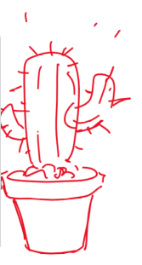
029. Elinor’s question: Why does a cactus have thorns?

It’s Plant Day at school! Elinor is excited to get a beautiful plant to take home. Ms. Mole is going to hand out several plants for some of the kids to take home, care for them, and then report to the class how it went. But when Ms. Mole hands out the plants, all the pretty or fun plants get taken by other kids, and she is left with a cactus, which looks neither pretty nor fun.
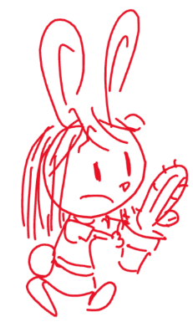
She seems disappointed at first, but when Hazel and Ari interact with her plant, it raises her curiosity. Hazel reads the plant’s instructions and says that the plant only needs to be watered once a week. And Ari gets gently poked (in a funny way) by the spikes. It makes Elinor wonder, why is this plant so different? Why does it have spikes and no leaves?

They consider some ideas:
- Because the cactus is mean? But she knows that plants don’t have feelings, so this can’t be right
- Does it need to poke people (like shots at the doctor)? That doesn’t make much sense.
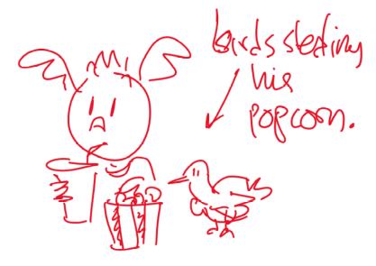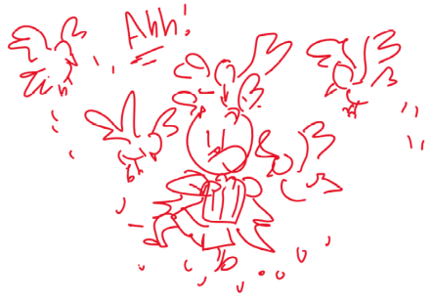
Elinor can’t figure it out, so she needs MORE OBSERVATIONS. They make a list of ways plants and cacti are similar and different, and walk around comparing the plants. They noticed that the cactus is bulbous, not thin and dry-looking like most plants. When Hazel accidentally pokes the cactus with a dry stick, they realize maybe the reason the plant doesn’t need as much watering is that it already has a lot of water inside. At that moment, Ari gets hungry and starts to eat a bag of popcorn from his backpack. Some birds that have been following them along land next to Ari and try to steal his popcorn. Ari tries to fend them off, but there’s a lot of them! He wishes he had a way to keep the birds away. This makes Elinor realize the spikes in the cactus are to keep animals from stealing its precious water.

Back in school, Elinor gushes about how cool the plant is in her class presentation.

This is sweet, but quite small for 11 mins. Maybe that’s good thing?

I think it would be better to observe cacti in the desert.

Maybe combine this with the Soup Episode?

030. Elinor’s question: Why do birds sing?

It’s morning in Elinor’s Town. Elinor is happily sleeping in her bed. Suddenly, a bird lands on the tree outside her window and starting singing. This wakes Elinor up, who tries to ignore it and go back to sleep. After a beat, the bird starts to sing again, waking her up again. She walks down to breakfast, looking a little sleepy. Her parents ask her how she slept and she tells them about the bird. She asks her parents why birds sing? They have fun coming up with ideas:
- Maybe birds just like music… but they haven’t ever seen a bird attracted to their music, or dancing to music
- Maybe birds are practicing for a big performance, that's why they do the same song over and over…. But has anyone seen a bird performance?
Her parents aren’t sure what the answer is, which makes Elinor very curious to know. Her dad gives her a pair of binoculars and encourages her to observe them to try to find out.
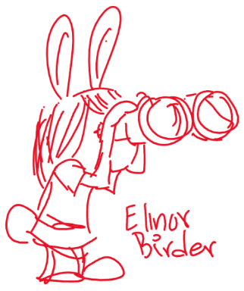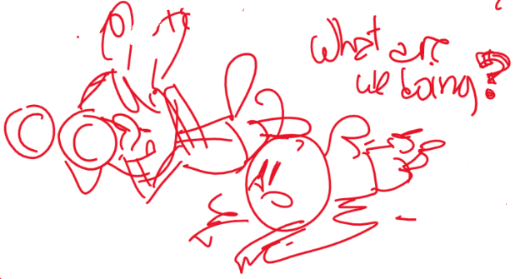

As she’s walking looking for birds, Ari and Hazel join her, and they decide to help Elinor observe birds. They all crouch down in the same spot to listen for birds. When they realize there are lots of birds in the area, they decide to split up.

Now that they are in separate parts of the forest, they have to shout to communicate: to identify themselves (It’s me! Hazel!!), find each other (Where are you!?), warn each other (Watch out for this rock!), claim territory (This is my spot!). Each time, Elinor notices that birds seem to be doing similar things (identifying themselves, finding each other, warning and claiming spots), but that the kids’ shouting scares the birds away. Elinor realizes the birds sing to communicate, and figures out a way to communicate with her friends without shouting: they whistle to each other, like the birds!

The next morning, Elinor is woken up again by the singing bird, but this time she knows the bird is just talking to other birds, so she snugly goes back to sleep.

I like this but I wonder will Elinor actually be able to discern the reasons for the animal calls by observation alone? Maybe one of Hazel’s books would help. Maybe a “talking book” that actually makes the sound?

031. Elinor’s question: why do birds lay eggs?
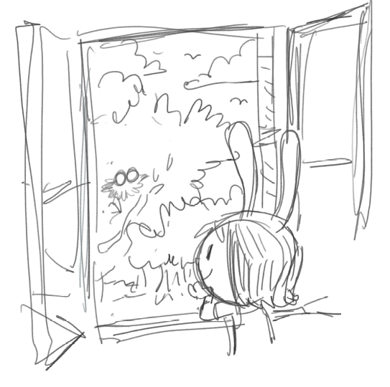
Elinor wakes up one morning and goes to say hi to the bird that lives in the tree outside her window. This time, she spots something new: two little eggs in the nest!

At school later, she enthusiastically describes to Hazel and Ari what she saw. Hazel informs her those are eggs, and that’s how birds make babies. Elinor wonders why they put the babies inside the eggs. At that point, Ari falls off the playground tricycle, but fortunately he’s wearing a helmet. This makes Elinor realize the eggs are there to protect the baby birds. Hazel asks if they can come over to look at the eggs.

The next morning, Elinor, Hazel and Ari are in Elinor’s bedroom looking at the bird nest. They see the mama bird return and sit on the eggs.

Back in school that day, Elinor, Hazel and Ari are excitedly telling the other kids in class about the bird nest. They all wonder why the mama bird sat on the eggs. They decide to sit on rocks to see what would happen. At first, the rocks are cool, but afterwards the rocks are warm. They realize that the mama bird must be keeping the eggs warm. The other kids ask if they can come over to look at the nest.

The next morning, Elinor, Hazel, Ari and all the kids from the class are crammed around Elinor’s bedroom window looking at the bird nest. As they are watching, one of the eggs moves!

Back in school that day, all the kids are excited to tell Ms. Mole about the bird eggs. Ms. Mole recaps what they’ve learned: eggs are how birds make babies, the mama sits on them to keep them warm, and the eggs protect the babies. The kids then wonder, if the eggs protect the babies, how are the babies going to come out? Ms. Mole doesn’t have an immediate answer. One of the kids in the class says they should ask their parents. The others nod in agreement.

The next morning, Elinor, Hazel, Ari, the kids in the classroom, Ms. Mole and THE ENTIRE TOWN (it seems) is crammed into Elinor’s bedroom. Elinor’s mom and dad try to figure out how to host so many visitors. Everyone is looking out the window, wondering when, and how, the eggs will come out. Suddenly, one of the eggs stirs, cracks and out comes a hatchling! The whole town cheers. Elinor figures out that the egg must be hard enough to protect the baby, but not so hard that the baby can’t get out when it’s ready. The crowd leaves in a celebratory mood, and Elinor’s parents are happy but relieved.

A morning in the future, Elinor wakes up and runs to her window. In the nest are the little baby birds, and she sees one of them jump off and fly away.

Okay, I read this one several times and I was confused every time. This is GOOD NEWS, because I’ve read over 30 stories by now, and this is the first one I truly didn’t understand.

For one thing, the question is not really answered. The REAL answer to “Why do birds lay eggs” is because the baby birds inside are not developed enough to survive in the world yet, and a mother bird couldn’t fly with a baby developing inside her (the way mammals do) so the baby has to grow OUTSIDE the mother. In an egg.

But I suppose another way of looking at ti is that “Birds lay eggs to protect the babaies inside” but if this is the case the problem is solved in the first act, so the rest of the story seems superfluous.

Maybe this is one of the stories that needs more STORY! What does Elinor want, besides the answer to her question. I think it might be more “How do I help this Mamma bird take care of her eggs?” The answer to that would be to leave them alone, of course. But Elinor can observe. It might be nice to see her build up a REAL relationship with the birds, and be rewarded at the end for her careful attention.

Maybe this is a story about patience, and the rewards of waiting?

Not crazy about the whole town being stuffed into Elinor’s room to watch the egg hatch, seems disrespectful somehow, certainly the older folk would know you shouldn’t harass birds, but observe them quietly.

This story also has A LOT of back and forth between home and school, and it takes place over several days. We have to watch this – the passage of time gets confusing for preschooler, while we can do it. Its better to avoid.

I would put this one aside for now.

032. Elinor’s Question: What do plants need?

It’s Plant Day at Elinor’s school once again, and this time it’s Ari’s turn to take a plant home and take care of it. Ari gets a regular simple plant, and when Elinor and Hazel offer to help him take care of it, Ari tells them not to worry. Ari says he’s an expert at taking care of things because he helps take care of his baby sister all the time.

When he gets home, Ari tries to take care of the plant in the same way he sees his parents taking care of his little sister. He puts diapers on the plant. He lies it down in a basket (which spills some of the soil) and covers it. He tries to feed it milk from a bottle. He reads to it. A few days later, Elinor and Hazel come over to visit, and when Ari shows them the plant, they see that the plant looks kind of sad (a little droopy). Ari doesn’t understand why, since he’s done everything the same way as his parents do for his sister. Elinor suggests that maybe plants and bat babies need different things. They decide to go to the forest to see how plants take care of their baby plants.
As they walk around, they realize that all plants really need is soil, water and sunlight. They go back to Ari’s house and stand the plant up, put the soil back in the pot, add a little bit water and place the plant near the window. Almost immediately, the plant seems to perk up. Ari sighs a big sigh of relief.

Back in School, Ari reports on his experiences, and Ms. Mole says maybe Ari can take Mr. Beeker (the class lizard) home next time. Mr. Beeker looks worried and gulps.

This is REALLY cute and kid-relatable!!! Lots of room for comedy here, and to see things from Ari’s pint of view, and to meet his family!!

037. Elinor’s Question: Why are there so many different kinds of plants?

Elinor, Hazel and Ari are walking through the forest in their team uniforms on their way to soccer practice. Hazel hurries them up (they’re late!), as Elinor and Ari toss the soccer ball around. Ari kicks the ball into a bush and Elinor goes to get it. As she steps out, she realizes she’s standing next to a small bush, a medium sized tree, and a giant tall tree.

At soccer practice, Ms. Mole has them doing drills. Elinor tries to run fast, but Silas Cheetah is obviously the fastest runner. She tries to be the best ball dribbler, but Huey Mouse can scurry around faster. She tries to be the best kicker, but the goat twins can back kick the ball farther. She’s not even the best water drinker. Camilla Camel doesn’t even need to drink and just sips gracefully out of a teacup!
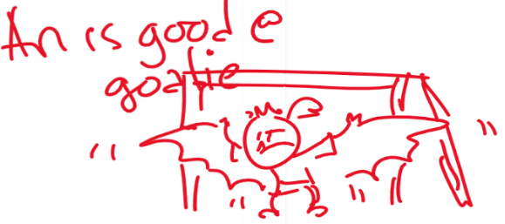
When they start playing games, even her two best friends are really good at something: Ari is the perfect goalie (his wingspan and echo location help stop any balls), and Hazel can do alley oops and tricks with her trunk (some kids cry foul, but Ms. Mole reminds them that you can use your nose to hit the ball).

Elinor is feeling bummed that she’s not as good at soccer as everyone else, and goes to sit on the bench. Ms. Mole notices she’s bummed and goes over to talk to Elinor. After Elinor tells her what’s wrong, Ms. Mole points Elinor to the trees surrounding the field, and asks Elinor if she notices something. Elinor notices there are all kinds of different plants, from little plants, to bushes to vines to giant trees. There are sooo many different kinds of plants. Why are there SO many? Why isn’t there just one kind of plant? They all are green and drink the sun, so why so many different kinds? Ms. Mole asks her what she thinks, and she has some silly ideas:
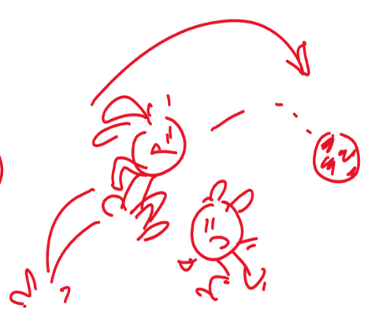- plants are very proud and want to stand out?
- plants can’t agree on what’s best
- plants are too disorganized

This would DEFINITELY be better if Elinor comes to this on her own, just by closely observing the plants. She has enough knowledge to come to these conclusions herseld. 1) You are good at making flower. 2) You make lots of shade 2) You make yummy apples. 4)You make the ground nice and soft to lie on.

Eventually, she realizes that every plant must be good at something different and that’s why they are part of nature.

She understands that there are lots of ways to do the same thing (get water and sun) and that plants have a lot in common with each other but they don’t have to be identical. In the same way, we find the best way to use our skills to accomplish our goals.

After realizing this, she is energized to play again, and figures out that hopping and jumping is something she’s really good at, and she’s able to toss the ball up and jump up over other players. At the end of the practice, she shows off: I didn’t even get to use my ears (she handles the ball with her ears)! All the other kids go, hey!!
038. Elinor’s Question: How do plants know which way is up?

Elinor’s class is growing some seedlings to plant around the school. They pack them in dirt and give them water and put them in the sun. A week later, they all sprout and Elinor, Ari and Hazel take good care of their seedlings. But they come in after a weekend and find that one of the seedlings looks a lot different:
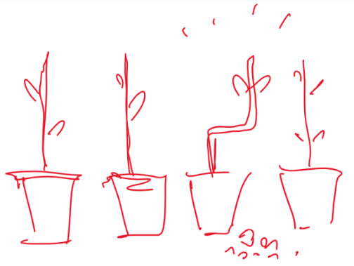
It looks like a zig zag!

The kids are completely puzzled by this. It’s a mystery! Elinor decides they must know the answer and begins an investigation. They consider the possibilities. Maybe this is a different kind of plant? They check and confirm that this is the same type of plant. Maybe it’s in a different kind of pot or soil? Nope, also the same. They start to think about what determines which way plants grow.

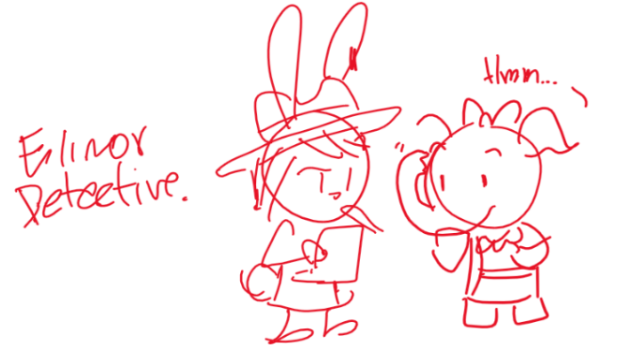Proceeding like a detective story, the kids try different things and interview the rest of the kids in class and Ms. Mole. Slowly the piece together what happened: Ari knocked over the plant right before they left for the weekend (hence the small amount of dirt near the plant), but at some point in the middle of the weekend, Ms. Mole came into school to tidy up, and put the plant right side up. Since plants always grow up (in the direction away from the ground), the seedling grew into a zig zag shape!

Having solved the mystery of the zig zag plant, the kids try to experiment: they make a whole row of zig zag plants and plant them in the garden.

Really love the “detective” arena, would suggest we figure out some fun vocab “Detective Elinor is on the case!” and roles for everyone to play, we may be back!

Really like the zig-zag plant, very kid-relatable.

But this one may need some work in terms of the curriculum/learn. For me, the link between the natural world and the designed world is not as strong as other stories, as the kids basically design the exact same thing “zig-zag plants” as nature has already done – although the zig-zag garden is admittedly cool.

That being said there are a lot of stories to do, and I know not all will have such a strong link between the two goals – some, like this one, may be more exploratory. So maybe it’s okay.

Also, this story is a little tricky for the age-range as the solution to the mystery has to do with something that happened in the past, which is a concept our younger viewers are just beginning to grasp. As a rule flashbacks never work in preschool, because the kids don’t understand the concept.

This isn’t a deal-breaker, though, as I think we are going for upper preschool, we just need to be mindful that the younger viewers might not completely understand. But as long as the story is compelling they will follow along, becoming exposed to concepts a little above their heads (which happens all the time).

Most importantly, though, preschoolers really need to see something happen to understand it. An easy solve would be some kind of a security camera so we can see an IMAGE of what has happened. Or if a security camera is too creepy then maybe Ms. Mole set up a camera to record the plant growth (LOVE Ms. Mole BTW)

- Curriculum: are they on topic? RTL will require that we hew pretty close to the learning goals.

LS6. Understand that individuals of the same kind of plant or animal are recognizable as similar but can also vary in many ways:

ND4. (RTL Crosscutting concept ‘Flows, Cycles, and Conservation’): Appreciate the way that elements in the natural world change, interact and are re-used, and how we can organize our designed world to better fit and care for the environment. NOT SURE ABOUT THIS ONE:
SI - TBD

- Story: will they make for engaging stories? Are there opportunities for physical humor and silliness?

Yes! I think the detective arena has us pretty well covered in this regard. However I do worry a little about the fact that they are inside the whole time, and wonder if maybe they should go outside and observe how other plants grow and make room for physical comedy.
(3) Character: are they in line with the characters we created? Do we learn something about the characters?

I really like Elinor’s role-playing in this, and that she assumes her natural leadership role through a game that she invites others to play. I think this is something we should dig into more deeply as the series moves along (i.e. Explorer Elinor, Astronaut Elinor, Doctor Elinor).

I also think it would be great if she gives specific and character-driven jobs to Hazel and Ari as they help out in her investigation. i.e. Hazel is the Clue Expert, and she writes everything in the notebook, and Ari is in charge of the magnifying glass (or something)
039. Elinor’s Question: how do snails shells grow with the snail?

I WOULD LIKE TO WRITE THIS ONE UP!

It’s a beautiful morning in the Elinor’s Town and Elinor and her friends are playing in their clubhouse. The clubhouse is really just a big cardboard box that they cut out a door and some windows. Their club has a name: “The Explorer’s Club”

Elinor calls today’s meeting of the Explorer’s Club to order. Today, they are inducting two new members: Sally Beaver and Kai Wombat. As they are playing, Ari looks out the window notices a snail crawling up a nearby branch. The snail is being trailed by a baby snail, which looks the same but smaller.
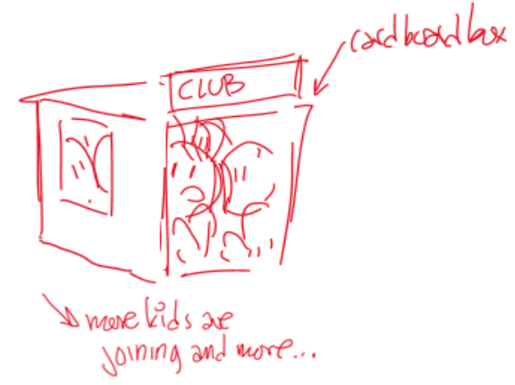
At that moment, more kids show up wanting to join the Explorer’s Club. Elinor and her friends confer, and decide that exploring is something that is open to everyone, so they decide to induct more members. Even though it’s getting crowded, they repeat the induction ceremony and welcome the new members.

As they get ready to actually go explore, more kids show up wanting to join the club. Elinor is not sure what to do, but inducts them anyway. Soon, the clubhouse is getting overcrowded and they can barely fit inside the cardboard box!

The kids decide that their first order of business should be to get a bigger clubhouse. They consider the possibilities: they could get another box, and have two clubhouses. But then they would have to shout across the field to have meetings. They could get a bigger box. But how are they going to get such a big box? And what if more kids show up?

A distracted Ari finally chimes in: How do snails grow their shells? Do they make a new one and move into it? But he’s never seen a snail making a new shell?

The Explorer’s Club is intrigue. Elinor declares they need more observations and all the kids fan out to look for more snails.

Elinor gets an idea: the snails are adding to their shells! She looks at an empty shell and sees that it winds around, starting small and getting bigger. So the snail can always add a bit to the outside to make it bigger.

This inspires in Elinor an idea for the Club. They expand the box, instead of getting a new one, and they get plenty of materials in case more kids show up.

Love this for a lot of reasons. An ALL- INCLUSIVE CLUB – YUUUUS!!
Clear link between natural world (snail shell) and designed world (club house). This one is great.

The snails can be the club mascots! I like that there is a smaller snail too (maybe a baby sister), so we can compare snail shells on live snails.

Just a head’s up that what you’re describing might be a bit tricky for design. i.e. stuffing so many kids into such a small space and having the action take place INSIDE the club house. Would be good to get them outside for part of the show, and maybe the snails are the answer – it’s just too crowded for them and they take off (slowly), so the kids are like “Hey! Where did Morty and Louise go?” A little search reveals the clubhouse is too cramped for even the snails, then a brainstorm (great SI modelling). Then the design and execution of the club house reno (all outside).

The animators may also flag this as they are usually kind of allergic to crowds of any kind. They may ask us to use as few kids as poss, and I don’t think that’s a problem – 5-6 kids will be enough (Elinor, Ari, Hazel and two or three more). We just need to always be mindful of possible animation concerns (I have a lot of experience with this).

- Curriculum: are they on topic? RTL will require that we hew pretty close to the learning goals.

LS4. Understand that all animals and plants have a life cycle, can reproduce, and change and grow over time:
ND3. (RTL Crosscutting concept ‘Structure and Function’): Understand that structures and materials in the natural world can be used or can inspire the engineering of structures with similar function in the designed world.
SI – TBD.
(2) Story: will they make for engaging stories? Are there opportunities for physical humor and silliness?

Oh, yes this can be really fun – think clown-car fun, and maybe even the clubhouse (box) rolls away with the kids inside.

Also I think it’s pretty funny that it’s an Explorer Club but really all they do is stay in a box! Making fun Explorer plans, I assume.

We also have lots of room for fun Explorer role-playing – maybe Ari has a telescope that he insists on looking through all the time, with hilarious results. Or Hazel has a map she just can’t fold – fun silly stuff.
(3) Character: are they in line with the characters we created? Do we learn something about the characters?
Yes, I think this is another great opportunity for Elinor to assume her natural leader role through pretend play and we can really explore character here as she decides WHY each person is a truly exceptional member of the Club – we can’t have a club without Ari – he has super-sonic hearing (or whatev).

041. Elinor’s Question: Why do lizards sit in the sun?

It’s a sunny day in the forest, and Elinor and her mom an her friends are walking around. Ari complains that it’s very hot, and takes a rest in the shade where it is cooler. They come upon Mrs. Beaver, who is in the middle of a construction project to a new house for Mr. Antelope. Unfortunately, though, all construction has come to a halt, as there are two lizards sitting on a rock in the middle of the clearing where the house is supposed to be built. The lizards won’t budge, and they can’t shoo them away because they are a protected species. The lizards eventually leave at the end of the day, but they come right back each morning. Mrs. Beaver is afraid they’ll have to cancel the whole project.
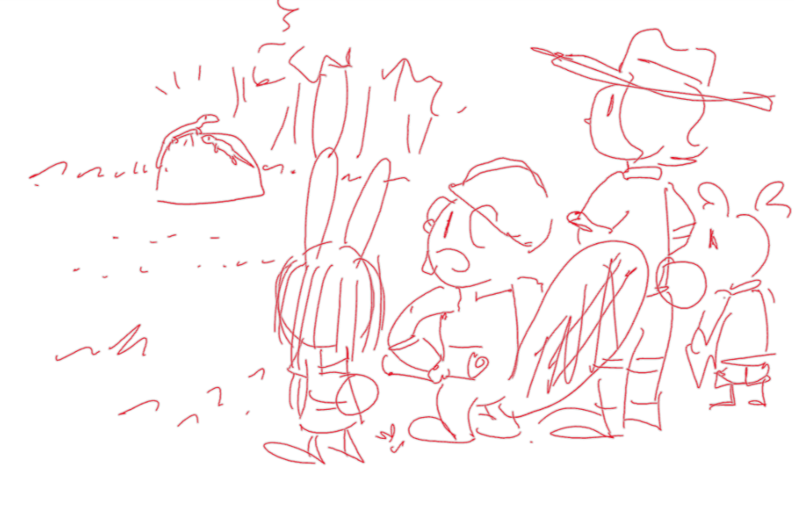
Elinor wonders why the lizards are just sitting on the rock in the sun. Elinor’s mom suggests that if they knew why, maybe they could figure out a way to get them to move to a different rock. The kids come up with different ideas for why the lizards might be sitting on the rock. Hazel looks up lizards on her nature book, and we learn some basic facts about lizards, including the fact that they are cold-blooded (i.e. they can’t get warm by themselves). As Ari says he feels hot again and looks for some shade, Elinor hypothesizes that maybe the lizards are just trying to get warm. Elinor devices a plan: if they can shade the rock in the middle of the clearing, maybe the lizards will want to move to a different rock. They find a different rock and move some branches to make it sunny, and then Ari hovers over the lizards (working up quite a sweat). Soon, the lizards decide to move to the other rock, and everyone cheers. As Mrs. Beaver resumes her work, a tired Ari plops down in a different rock in the shade and wishes he was cool like the lizards, in more ways than one!
If we put Elinor’s Grandparents in the desert, then this can be a Grandparent story.

Maybe Grandpa is just building a shed. Maybe he just doesn’t want to shoo away the lizards because they were there first, and it’s respectful. They don’t need to be endangered to be left alone, do they??

Let’s lean on the “Lizard Lounge” a rock in a perfect spot where the lizards can lounge in the sun.

PERSONALLY, I would avoid Mrs. Beaver’s big project – it feels so much like urban development (because it is). Let’s kleep the projects small and preschool as much as possible, although I know everyone like a good bulldozer.

DIGRESSION DU JOUR: there is a lot of development happening in my neighbourhood which is right beside a National Park (literally, the Park is my next-door neighbor). We used to all be on wells, then we got city water and BAM!!! 1000 new houses within a kilometer of me (on the other side).

It breaks my heart when I drive along a new road (where I used to walk my dog by the swamp) – I see deer wandering around the construction site, confused, and try to swerve around the frogs who are searching for their now-destroyed swamp. We just OBLITERATE THEIR HOMES AND WE DON’T EVEN SAY SORRY!!!!!!!!!!!!!!!!!!! (rant over)

042. Elinor’s question: Are there plants and animals on the moon?

Elinor and her dad are sitting outside, enjoying the night air. The clouds part and the moon comes out. They look at it through a telescope and comment on how round it is and how bright it looks. Elinor wonders, “are there plants and animals on the moon?” Before her dad can answer, Elinor’s mom calls them for her to go to bed.
The next day, Elinor and her friends are wondering about this question. If there are plants and animals all around them, why can’t there be plants and animals on the moon? They discuss different ways they could find out: they could go to the moon (but none of them know how to get there). They could get a bigger telescope, but none of them know where to get one. Finally, Elinor has an idea: they could ask a lot of different people, and see what they think.

The first animal they talk to doesn’t give them an answer, but fills them in on what the moon is: it’s a big round rock in space that moves around the Earth.

The second animal doesn’t know either, but they guess that there are probably a lot of plants there. This animals guesses that the moon is covered in green plants.

The third animal doesn’t know for sure either, but gets the kids to think about what plants need: air, and water and sunlight and dirt.

The fourth animal is the librarian, and brings out for them pictures of the moon. The kids ask questions and learn that there is no air or liquid water on the moon. The kids put together that there can’t be any plants there because they don’t have the things they need. They also check that against their observation of the moon (it’s not covered in green plants), so *their* best guess is that there are no plants on the moon (and also no animals, because animals need plants to eat).

I like this story as it’s about asking questions rather than expoloring and observing.

LOVE that they go to the Library – would like to make this a bigger part of the show.

THIS SHOW will really help us did in to one key Question – how do we present information that the kids can’t actually see – suggestions in my notes.

This one lacks a “Designed World” Solution. Maybe the kids can design special moon flowers, that don’t need sun or water or earth – because they are made of contrusction paper.

045. Elinor’s Question: Why do birds have feathers?

Elinor is walking to school one day. She sees a bunch of birds in a tree, clustered together. One of their feathers blows loose and floats down to her. She picks it up and looks at it closely in awe.

In class, she shows it to her friends, and comments how cool feathers are. But she wonders what they are for? The kids decide to split up and get more observations.

The kids each observe different things about birds and they each come up with a different hypothesis: Elinor watches some birds spread their wings and fly and thinks that feathers help birds fly because they act like a fan and are really light; Hazel sees some birds play around and sing and, and thinks feathers are pretty and colorful and help birds make a fashion statement; and Ari sees birds huddle together in the cold gust of wind and thinks feathers are there to keep birds warm, like fur.

The kids get back together and they each present their hypothesis. There is a little bit of competition because each thinks they are right. At that moment, Ms. Mole comes in and starts asking about their clothes (which seems random to the kids). Slowly, the kids realize that clothes also serve multiple functions: they keep you warm, they make a statement, and they help your body keep from getting dirty. The kids realize feathers are good for a lot of things, and that’s why birds have them. Phew, says Ari, he feels light as a feather now that they solved the mystery!

This is a great core but feels a little light story-wise. Again, maybe this is okay – or maybe this is a good place for another “Detective Elinor” story.

Also it’s very much like the “Automatic Jacket” – which is better, because of the whimsey and the emotional stakes for Hazel.

047. Elinor’s Question: Do baby plants have parents?

Young animals and young plants are similar but not the same
The young are the same kind as the parents. Babies are little versions of adults.

Elinor is on her way to school. In a big open field, she sees a tiny little plant pushing its way up. She thinks its cute. She has a water bottle with her, so she gives it a few drops. Every day, she stops and checks on the plant and gives it water. One day some trash is stuck on it, so she clears it off. She likes taking care of it, and it begins to grow until she can tell it’s going to be a tree.

She tells Ms Mole all about it during show and tell one day. MM asks her what made her want to take care of that tree, and she says that it just seemed all by itself, and that now she likes taking care of it, since it didn’t have anyone else to help it. That makes her wonder: why didn’t it have anyone else? Do plants have parents anyway?

She feels like a detective, on the case. She and her friend brainstorm how they are going to figure it out.

They go take a more careful look at the little tree and draw the shape of its leaves.

Now they need MORE OBSERVATIONS. They look at the big trees nearby and draw the shape of their leaves. They find a big group of old trees with leaves the same kind of leaf. They tell their parents, but they still don’t know which tree it was and why the little tree was so far away from it. They realize that trees don’t treat their babies the way animals do: they just let them grow up on their own. The kids are glad to be animals, and have parents that take care of them. Elinor says: except for this little tree. It has me to take care of it!

Okay so here we go with Detective Elinor. I like this story better than the feather one – there are more stakes for Elinor, it’s a truly poignant question “Do plants have parents” and she is more active – taking care of the saplin.

Something to think about – don’t trees communicate with each other underground through their roots? Would need to research this, I think it may be true for some species. If so this might be a way for Elinor to feel a little better once she figures this out. We are all connected!!

048. Why do termites make holes in wood? (they are eating it!)

Elinor and her friends are visiting Sally Beaver’s house, which is beautifully carved out of wood. While they are telling Elinor about how they designed it and carved it with their teeth, Elinor spots a small bug climbing out of a hole in the wood. She asks her friend what it is, and her friend turns white. “Oh no!” She goes to get her parents who get alarmed. It’s a termite! Elinor doesn’t know what a termite is, and her friend explains: it’s a little bug that makes holes in wood. Eventually it could make holes all over the house!

The kids go outside. Elinor is amazed. A tiny bug can cut through wood?!

They decide to try to find more of these bugs. After all the forest is filled with wood from trees. But after examining some trees, they can’t find any termites.

The kids wonder: How does it cut through wood and why? They have some ideas. Is it just building a home, like ants making tunnels in dirt? Dirt is so much easier, why would they use wood? [NOTE: it seems most termites live in mounds or “hive” like structures up in trees made out of their poop. Only some termites live in wood]

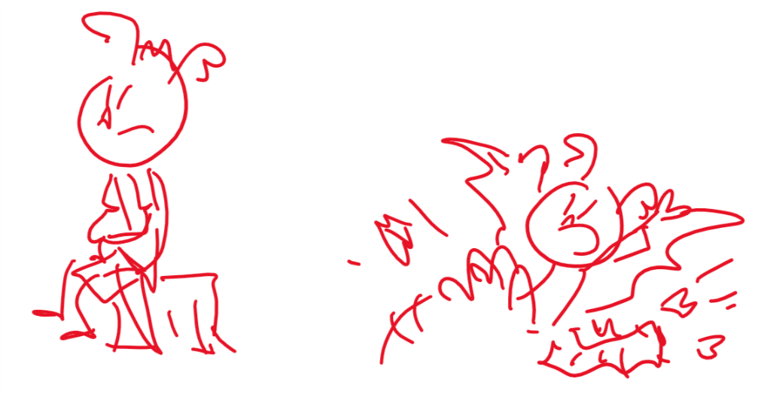
As they are about to give up, Ari sits down on an old log in a clearing. As he sits, the log collapses! It’s full of holes made by termites.

They take a closer look and watch as a termite chomps on the wood. It uses its mouth parts to cut and eat the wood! So they understand that the termite has super sharp jaws that can cut wood AND that it is EATING the wood. That’s amazing to them.

Ari thinks it's a cool idea: what if you lived in a huge block of chocolate cake, and when you wanted to make your room bigger, you could just eat the walls! Hazel points out that everyone else would also want to eat your house, and you’d be worse off than the beavers! Ari says: well, I would cover the outside with something gross, like brussel sprouts.

The kids realize that termites only seem to eat the old wood that is left over in the forest, which helps get rid of the things nobody wants, so they are helpful in that way. (Ari at the same time offers to eat the leftover cookies they were snacking on)

The kids visits the Beavers again. They have put something in the wood of their house that makes it yucky for termites. (Ari thinks this is a copy of his brussel-sprouts idea). The termites went back into the forest to eat old, dead trees. Ari wonders if there is any old chocolate cake in the forest he could eat.
I like that in this sorty we have the question AND the answer, but it goes a little off-track for me. I was worried about Mrs. Beaver’s house the whole time!! And I’m not crazy that Elinor goes to her parents for explanation.

There’s something in this for sure, though. And I think trial and error at Mrs. Beavers house might be the way, but I can’t figure it out right now – too many stories!!!!

