Comic 084

Panel 1: Elinor is observing a baby turtle that is crossing a path in the main part of Animal Town. Mr. Raccoon stands behind her and says, “Has the baby turtle crossed the path yet, Elinor?”
Panel 2: Elinor says, “Not yet, Mr. Raccoon. Are you in a hurry?”
Panel 3+4: On a double panel, we widen out to see a funny long line of town residents waiting behind Mr. Raccoon, who says, “I’m not, but they might be!”

Activity: TBD. Suggestions: Try playing a game of “Red Light-Green Light” but as a Turtle Crossing game! Have one person be the crossing guard and the others be turtles, and the crossing guard can call out red (stop), yellow (slow motion) and green (fast) to see which “turtle” can cross the finish line first!
PBS: No edits

Comic 085

Panel 1: Olive and Ari are standing on snow. Ari comments on Olive’s snowshoes, saying, “Nice snowshoes, Olive!”
Panel 2: Olive lifts a foot up and says, “Thanks! They’re wide and that keeps me from sinking in the snow.”
Panel 3: On a close up of Elinor, she says, “Look, I have snowshoes too!”
Panel 4: We widen out to see Elinor standing with her feet covered in big shoes sculpted out of snow. Smiling, she says, “I made them myself!”

Activity: TBD. Suggestions: Bathtub activity with water and surface tension – what happens when you drop things into the water on their own? Try putting them on top of a face-up paper plate instead – what happens then? How many toys can you balance before the plate sinks?
PBS: Cute! Does this activity have a close enough of a connection to the comic? Not sure parents/kids will see how surface tension of liquid water is the same as the snowshoes on snow.

Comic 086

Panel 1: We see Ari carrying a little bucket of sand with one hand and Rocky the Rock on the other hand. Elinor looks on as Ari says, “I’m making a snack for my pet rock Rocky!”
Panel 2: On a close view, we see Rocky the Rock and Elinor behind it as Elinor asks, “What kind of snack do rocks eat?”
Panel 3: We see Ari dumping the sand on the sandbox as he says, “What else...” (we see two leaves in the sandbox)
Panel 4: Ari holds up some sand in between two leaves as he says, “A SAND-wich!”

Activity: TBD. Suggestions: Paint a rock friend and take it around with you during the day!
PBS: Would be fun to have something in the activity related to comparing and contrasting living and non-living like in the related episode.

Comic 087

Panel 1: Elinor walks over to Olive, who is sitting under a tree reading. Elinor says, “What are you doing, Olive?”
Panel 2: Olive replies, “I’m reading a book with one of my best friends.”
Panel 3: Elinor looks a little confused as there is no one else around Olive. “Who?” Elinor asks.
Panel 4: Olive hugs the tree with one arm as she says, “This tree!”

Activity: TBD. Suggestions: If you were to pick a best friend in nature, what would it be and why? Go on a walk around your neighborhood or local park, and pick out a tree/flower/rock/insect as your best nature friend!
PBS: could also draw a picture of what nature material/object would be your friend.

Comic 088

Panel 1: Elinor, Olive and Ari are carrying sleeping bags in Elinor’s backyard. Elinor stretches her arm out and says, “I love backyard camping!”
Panel 2: On a close view of Olive, she asks, “Where should we put our sleeping bags?”
Panel 3: Olive and Elinor turn as they hear Ari offscreen say, “I found a spot!”
Panel 4: We go wide to reveal Elinor and Olive looking up at Ari in a sleeping bag hanging from a tree branch upside down. He says, “Ahh, just like my bed at home!”

Activity: TBD. Suggestions: Have a sleepover at home! Can you make a perfect place to sleep that isn’t where you normally sleep? Maybe a couch, or some pillows, or a fort you made out of cushions and sheets!
PBS: Can the activity connect to differences in how animals need sleep or where they sleep?

Comic 089

Panel 1: Elinor is standing at the edge of a lookout point (there’s a fence around the edge) with her Dad as she says, “Look how this cliff echoes, Dad.”
Panel 2: Elinor yells “HELLO!” and we see the echo come back, “HELLO!”
Panel 3: Mr. Rabbit says, “Let me try.” He yells out, “ELINOR IS CURIOUS!” and we see the echo come back , “ELINOR IS CURIOUS!”
Panel 4: Mr. Rabbit smiles and says, “Well, I can’t argue with that!”

Activity: TBD. Suggestions: Echolocation activity (like Marco Polo) – have Person A cover their eyes and use their sense of hearing to try and find Person B! Person B can make sounds with their mouth or with household objects like a spoon against a cup, etc.
PBS: No Edits

Comic 090

Panel 1: Elinor and Koa are behind some tall grass observing two frogs. Koa says, “I wonder if frogs have ears.” Elinor says, “They do!”
Panel 2: On a close up of one of the frogs, we hear Elinor say off-frame, “Frogs have covered ears so water doesn’t get inside when they swim.”
Panel 3: Koa raises his arms out and says, “That is SO cool!!” and we see the frogs leap away.
Panel 4: Elinor looks out smiling at the frogs hopping away and says, “See, they can hear you just fine.”

Activity: TBD. Suggestions: Try different ways to amplify the sound of your voice! Use an empty paper towel roll or a rolled-up piece of paper and see how your voice sounds different than when you’re speaking without it! (Try outside too, and see how the sound travels!)
PBS: No Edits

Comic 091

Panel 1: We see Olive and Sally standing and wiggling their ears as we hear someone say, “Big ears... small ear...”
Panel 2: Next we see Ari wiggling his ears and holding a book with a picture of a fish as the voice continues, “Floppy ears and inside ears!”
Panel 3: We see Elinor holding a piece of paper and studying it as she continues, “If we counted all the kinds of ears...”
Panel 4: On a wide view, we see she’s got several of her friends lined up, all of them wiggling their ears. She finishes, “We’d be counting ears for years!”

Activity: TBD. Suggestions: Try looking through an animal book or through different images of animals online, and draw the different ears on paper! What do you notice about the different shapes? Look at your own ears in a mirror and compare!
PBS: No Edits

Comic 092

Panel 1: Elinor is in Olive’s room looking at a stack of books on the floor. She says, “Wow, Olive, you have a lot of books.”
Panel 2: Olive looks at the stack and says, “Yup, I have books about almost everything!”
Panel 3: On a close view, Olive re-considers, “There is one book I’m missing...”
Panel 4: On a wider view, we see Olive surrounded by a few more stacks of books as she says, “A book about how to organize all my books!”

Activity: TBD. Suggestions: Read your favorite book together – why is your favorite book right now? Where do you keep it?
PBS: “What is your favorite book about nature/animals?” to connect more to the series.

Comic 093

Panel 1: Koa walks up to Olive and her little lending library and asks, “Do you have any books about surfing?” Olive replies, “Yup!”
Panel 2: As Olive reaches for the book, Elinor says, “Wow, Olive, everyone loves your lending library.”
Panel 3+4: (DOUBLE PANEL) We then see a wide shot of a whole bunch of kids lined up to get a book from the library. Olive says, “What can I say? Reading is fun!”

Activity: TBD. Suggestions: Locate the lending library closest to you (https://littlefreelibrary.org/ourmap/) and take a “field trip” to visit it! Maybe you can find a book that you enjoy, or you could even donate one of your old books!
PBS: No Edits

Comic 094

Panel 1: Elinor and Olive walk through the forest as they look up at a tree. Elinor says, “Look, it’s a bee hive!” (we see a beehive in the foreground)
Panel 2: Next, we see a close up of a bird’s nest with some chicks in it as Elinor continues from off-frame, “And look! A bird’s nest!”
Panel 3: Still looking up, Olive says, “There sure are some cool things in trees.”
Panel 4: In a wider shot of the forest, Elinor opens her arms and says, “Yeah, they’re sooo in-TREES-ting!”

Activity: TBD. Suggestions: Do some research about the parks or neighborhoods nearby and take a “tour” of each one throughout the month! What types of trees or flowers or creatures do you see in each one? (Can also: make a labeled drawing of each one in your notebook like a passport!)
PBS: Ask questions about what do you see above, under, in and on the trees?

Comic 095

Panel 1: We see Ari standing near a big tree near his house on a windy day as he tries to keep from getting blown away. He says, “It’s so windy today!”
Panel 2: Elinor also holds her hat down as she points to the tree’s roots and says, “Yeah, good thing trees have roots to keep them from falling over.”
Panel 3: We see a lightbulb turn on over Ari’s head.
Panel 4: In the last panel, we see a shovel and some loose dirt on the ground as we reveal Ari is now buried knee deep in the dirt and looking more relaxed. He say, “Ahh, that’s better!”

Activity: TBD. Suggestions: Toilet paper roll “root” activity – take a toilet paper roll and experiment with how well it can stand against wind (you blowing it!) a) on its own and b) if you cut strips into the bottom so they form “roots” and the roll can balance on them. [like the following image, except the cut parts are at the bottom!]
PBS: Perhaps an activity could be looking at the roots of trees outside –how big, long/far they stretch out, etc.

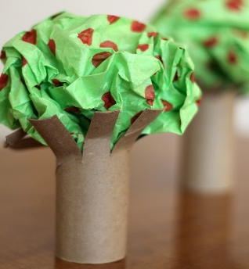

Comic 096

Panel 1: Olive gives a cut-out kid-craft butterfly to her mom as she says, “Happy Birthday, Mom! I made you a butterfly!”
Panel 2: Mom gives Olive a hug as she says, “Thanks, sweetie! But how did you know I like butterflies?”
Panel 3+4: On a wide panel, we see all the butterfly decorations around the kitchen, a magazine with a butterfly on it, Ms. Elephant wearing a butterfly apron and butterfly earrings. Looking around, Olive smiles and says, “Oh, I just guessed.”

Activity: TBD. Suggestions: Make a butterfly banner craft at home as decoration for a window!
PBS: Focus on decorating the butterfly wings with a fun pattern. There is a video activity that the PBS KIDS for Parents team is working on for Elinor Wonders Why – Butterfly costume – that we could also link to here.

Comic 097

Panel 1: Elinor and Olive are planting a small milkweed plant as Elinor says, “Butterflies like to visit special kinds of flowers.”
Panel 2: As she pats the dirt around the planting, she continues, “So if you plant them in your garden...”
Panel 3: She stands up and we see butterflies starting to fly into the frame. She finishes, “...the butterflies will come!”
Panel 4: We see Olive and Elinor surrounded by butterflies who are visiting all the flowers around them. Olive says, “Now that’s flower power!”

Activity: TBD. Suggestions: Scavenger hunt – go on a neighborhood walk and see if you can spot a butterfly! What kind of plants or flowers are they around? What colors do they seem to like?
PBS: No edits

Comic 098

Panel 1: Elinor and Olive are sitting at a table in school, making a craft out of yarn. Elinor says, “Making spiderwebs is so much fun!”
Panel 2: Elinor holds hers up and says, “Spiders make webs so they can catch insects to eat.”
Panel 3: Elinor looks over as we hear Olive say from off-frame, “Um, I need a little help.”
Panel 4: We reveal Olive all tangled up in her yarn web. She says, “My spiderweb caught an elephant!”

Activity: TBD. Suggestions: Spiderweb craft out of yarn – have parent draw a spiderweb on a piece of paper, and child can follow along the lines with glue and then with yarn or another kind of string! Can also add a paper spider!
PBS: Maybe let kids design their own web? The parents/caregivers don’t need to make the lines first. Here’s a similar activity <https://www.pbs.org/parents/crafts-and-experiments/paper-plate-spider-webs> that isn’t attached to a show that could work for this comic. It’s in the process of being edited and updated.

Comic 099

Panel 1: Elinor and Ari are in class carving pumpkins. Elinor stands next to her pumpkin (carved with a little ghost in it) as she asks to the side of her, “Are you done carving your pumpkin, Ari?”
Panel 2: We see Ari working on his pumpkin as he says, “Almost done...” (the pumpkin faces away from us, so we can’t see what he’s carving).
Panel 3: Ari proudly stands up and admires his work (still facing away from us) as he says, “Ta da! It’s my best work yet!”
Panel 4: Ari gestures to his pumpkin as we reveal he’s carved an Ari, complete with pieces of pumpkin for ears:
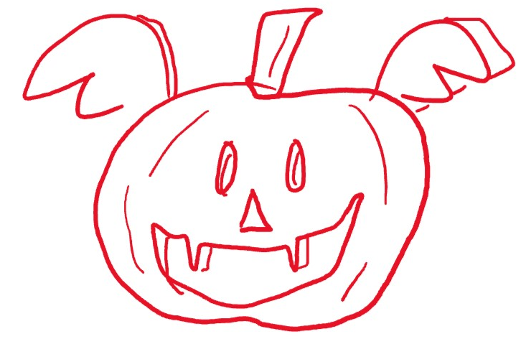
He says, “An Ari-o-lantern!”

Activity: TBD. Suggestions: Roasted pumpkin seed recipe (would need parent guidance with the oven and other supplies) – one savory option, one sweet!
PBS: No edits

Comic 100

Panel 1: Elinor and Ari are at picnic. Ari holds up a corn cob to his ear and says, “Look, I have an ear of corn!”
Panel 2: Ari leans over and says, “Get it? Because corn cobs are called ‘ears’!”
Panel 3: Elinor says, “I get it, Ari...”
Panel 4: She finishes with a big smile, “It’s a very corny joke!” Ari laughs too.

Activity: TBD. Suggestions: Turn your popcorn into jewelry! Popcorn necklace activity. Or Fun Fact: Corn always has an even number of rows on each ear.
PBS: We’re worried about using food for something other than eating. Maybe there is just a recipe for popping corn for eating instead? (Here’s a similar activity<https://www.pbs.org/parents/recipes/candy-coated-confetti-popcorn> connected to Molly of Denali)

